MGT 8803

Fundamentals of Analytics

# Summer 2021

# Introduction

Alan.flury@scheller.gatech.edu

Wen May 19th Weekly Video conference call

# Financial Accounting

## Week 1 05/17 – 05/23 Introduction to Financial Accounting

The focus in Financial Accounting is to help the student develop skills in reading and analyzing GAAP-compliant Financial Statements – including The Balance Sheet, Income Statement, and Statement of Cash Flows. This module introduces the basic structure and content of such reports. This involves learning what items are included in the financial statements, how such items are measured, and how and when various business/ economic events affect the financial statements. Students will acquire an understanding of what can be inferred from financial reports about the past operations, present position, and prospects of a firm. More broadly, students will learn how financial accounting information can be used to evaluate firm performance, to compare the performance of different firms, and to make a variety of important business decisions based on the analysis of financial statements and financial ratios.

Accounting represents historical view of the company. Finance is a look at the present or potential value of a company.

### Objectives:

* Describe concepts and standards underlying the measurements used in accounting to develop the financial statements of businesses.
* Analyze and account for business transactions.
* Classify and communicate the results of business transactions in the form of financial statements.
* Use and interpret financial information for making decisions pertaining to the business.

### Introduction to Financial Accounting

Financial Statement Qualities:

* Understandability
* Timeliness
* Full disclosure
* Comparability
* Objectivity (not accuracy as based on estimations)
* Decision relevance

Uses of Financial Forms:

* Health of Company
* Banker for evaluation for loan: Assets, Cash Flow, ability to repay, liabilities.
* Leverage debt to equity ratio
* Investors for dividends and year to year profit
* Bankers look at Cash to generate repayment loan

Forms of Businesses:

* Proprietorship & Partnership
  + Unlimited liability
  + No taxation
* Corporation (Shareholders, Board of Directors, Top Managers)
  + Limited liability
  + Taxation
  + Corporations can be publicly traded or privately held.

Assumptions

* Separate entity - We treat the business and the owners as separate entities, focusing on the accounting for the businesses, not the owners.
* Unit of measurement - The currency in which the company is operating.
* Going concern - We presume that the company will continue to operate -- that it'll be ongoing
* Periodicity - We presume that we can arbitrarily pick any time period that we want to and report the financial results for that time period.
* Materiality -the only information that needs to be disclosed in financial statements is information that will be useful for those who rely on the financial statements to make decisions.
* Generally Accepted Accounting Principles (GAAP) – focus here not on tax accounting.
* Securities & Exchange Commission (SEC). The rule-making resides under the authority of the SEC.
* Financial Accounting Standards Board (FASB). FASB consists of representatives from public accounting firms, industry, government agencies, and academia.
* International Financial Reporting Standards (IFRS)
* Qualities of Financial Statements - Understandability, Timeliness, Full disclosure, Comparability, Objectivity, Decision relevance
* Shareholders are stockholders

Financial Statements

* Balance Sheet
* Income Statement
* Statement of Cash Flows

Be able to read and prepare statements.

### Balance Sheet

Measures financial position at a point in time. Assets, Liabilities, and Owner's Equity. This is not the value of the company. For example, the cost principle does not use market value for assets, only purchase price. Carries over from year to year. All assets are stated at historical costs so does not reflect the current value of the company.

Resources = Sources of funding

Resources = Creditors’ claims + owners’ claims

Typically shows two years of history.

#### Assets

* Assets: Resources owned or rights to receive resources (Physical, Intangible, Legal rights)
* Common asset accounts: Cash, Accounts receivable & notes receivable, Inventory, Investments, Buildings & Equipment, intangible such as Copyrights; patents
* Order of presentation: liquidity
* Asset Valuation Options
  + Historical cost (objective)
  + Sales value (decision making)
  + Replacement cost
  + General price-level adjusted costs
* Cost Principle: Assets are valued at their historical cost (most objective) not appraised or market value. Cost is original value.

#### Liabilities and Stockholders’ Equity

* Liabilities: Obligations owed to creditors. Cash or goods and services.
* Dividends – distribution of earnings
  + declared are a liability.
  + reduces retained earnings as soon as they are declared.
  + only on balance sheet – not income/expense
  + company does not pay taxes on dividends.
  + recipient of dividends does pays taxes
* Common liability accounts: Accounts payable, Notes payable, Interest payable, Deferred (Unearned) Revenues, Accrued wages and salaries
* Classified Balance Sheets Shows Distinction
  + Current (conversion to cash within a year) vs. Long-term Assets (assumed on balance sheet)
  + Current (due date within a year) vs. Long-term Liabilities (assumed on balance sheet)
* Owners' Equity (OE) - Residual interest of owners to assets
* Accounting Equation:
  + Assets = Liability + OE (claims against assets) - (if liabilities decrease then assets decrease as well)
  + Assets – Liability = OE
* Stockholders' Equity - OE for corporations
  + Capital Stock Capital - what the company received when selling shares of its stock.
  + Retained Earnings – accumulated earnings less dividends. Dividends are a distribution of earnings, and that only occurs when the board of directors decides to distribute the earnings.
* Statement of Retained Earnings
  + Beginning Retained Earnings + Net Income – Dividends = Ending Retained Earnings
* Statement of Stockholders’ Equity
  + Beginning Stockholders’ Equity + Net Income – Dividends + Issuance of Capital Stock = Ending Stockholders’ Equity

### Cash Basis vs. Accrual Accounting

* Accrual Accounting
  + accrual accounting - Revenue is recognized when earned such as when services performed.
  + Revenues: Value received for goods sold or services performed - Revenue Recognition Principle when earned
  + Expenses: Payment, or obligations, for goods or services received
* Cash is not necessarily involved in the determination of revenues or expenses.
* cash basis accounting,
  1. revenues will be recognized when cash is received, and expenses will be recognized when cash is paid out.
* Income statement uses accrual accounting. Report revenue when earned.
* Dividends are not expenses but distributions of owners equity so they are not on an income/expense statement
* GAAP uses accrual accounting.
* Matching principle –
  1. Costs are reported as expenses in the same time period as their related revenues.
  2. Costs that cannot be matched with specific revenues are matched with future time periods that benefit from the cost.

### Income Statement

Income Statement Shows the results of a company’s operation performance (i.e., success or failure) over a period of time with a minimum of a year or 12 month fiscal year. Do not carry over from year to year.

Typically shows 3 years of history.

* Single Step Income Statement
  + Revenues Earned - Expenses Incurred = Net Income
  + Lists all our revenues and all expenses
  + Companies may have additional categories in it (e.g. net sales)
* Net Sales (Revenues) - Cost of Goods Sold = Gross Margin (Profit)
* S, G & A – Selling, General, and Administrative
* Operating Expenses (S, G & A) = Operating Income +/- Other Rev. & Exp. (Gains, Losses, Interest, Div. Rev.)
* Income Before Taxes-Income Tax Expense = Income After Taxes
* Earnings per Share (EPS) = Net Income (Net Loss) (minus preferred dividends) / # Shares of Stock
* Basic EPS as shown
* Fully diluted EPS – include potential shares such as stock options and restricted stock units

Net Income

### Statement of Cash Flows

Statement of Cash Flows Shows how cash changed from the beginning to the end of the period. Question 23: Reports the amount of cash collected and paid out by a company in operating, investing, and financing activities.

Investing Activities Buying and selling long-term assets (land, building, equipment).

Financing Activities Cash obtained from or repaid to owners and creditors (loans, repayments, stock issuance).

* + Investing cash flows + Financing cash flows = Change in cash
* Cash Flow Statement Three parts
  1. Operating Activities - A company’s day-to-day activities.
     + Major operating cash inflow—cash receipts from selling goods or from providing services.
     + Major operating cash outflow—payments to purchase inventory and to pay operating expenses.
  2. Investing Activities - Buying and selling long-term assets (land, building, equipment)
  3. Financing Activities - Cash obtained from or repaid to owners and creditors (loans, repayments, stock issuance).
* Direct vs. Indirect Methods
  1. Direct method explicitly states where the cash came from and where the cash went to. More time and effort.
  2. Indirect method starts off with the company's net income from the income statement, and it makes some adjustments to get to the cash flow from the operating activities.

### Audits

* Issued by independent CPA firms.
* CPAs attest to conformity with GAAP ("present fairly").
* Financial statement opinion:
  + unqualified (clean)
  + modified (going concern) - qualified opinion GAAP violation (e.g. inventory not properly accounted for)
  + adverse – finances as a whole are not being properly presented
* Financial statements are the responsibility of the company’s management and not the CPA.
* Sarbanes-Oxley Act of 2002: opinions on internal controls

## May 19 Conference Call

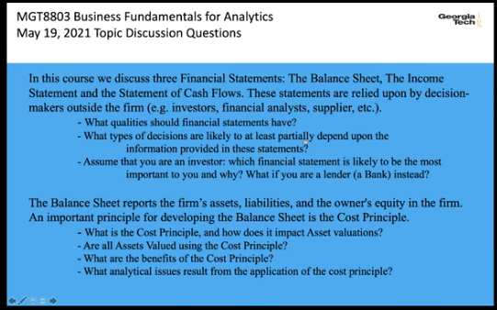

## Week 2 05/24 – 05/30 Assets, Liabilities, and Owners Equity

### 1. Cash and Accounts Receivable

* Cash - Anything a bank will accept for deposit:
  + Checks
  + Money orders
  + Bank credit card slips, visa, mastercard
  + Cash Equivalents. Investments due within 3 months.
* Accounts Receivable A/R
  + Own credit card such Macy’s are accounts receivables A/R
  + Bad debts – Only on income sheet
    - Do not reduce net sales. Instead, record a bad debts expense.
    - For Income Statement - Matching principle for Bad Debt Expense in the same period
    - For Balance Sheet: A/R (net) = A/R – Allowance for bad debts – Estimate Losses for matching principle
    - Accounts receivable - Allowance for bad debts – contra-account on balance sheet
    - Estimation Methods
      1. Percentage of Credit Sales Method
         * Bad Debt Expense = Percentage of credit sales
         * [This amount is added to Allowance for Bad Debts]
         * Direct method cannot be used for bad debt with GAAP
         * Bad debt expense is an account that appears on the income statement, so it does not carry over from one year to the next.
         * The allowance account is a balance sheet account. It does carry over from one year to the next. The amount at the end of one year becomes the balance at the beginning of the next year.

Example:

Bad Debt Expense = 2% of $500,000 credit sales = $10,000

* + - 1. Percentage of Receivables Method
  + New Allowance for Bad Debts = Percentage(s) of ending balance in A/R
  + Bad Debt Expense = New Allowance for Bad Debts – Previous Allowance for Bad Debts

Previous Allowance for B.D. = $1,800

Ending balance of A/R=$100,000.

Example of 4 ages for Aging of A/R:

< 30 days: $62,000 x 1% = $620

31-60 days: $15,000 x 3% = $450

61-120 days: $20,000 x 7% = $1,400

>120 days: $3,000 x 20% = $600

New Allow. for B. D. = $620 + $450 + $1,400 + $600 = $3,070

Bad Debt Expense = $3,070 – $1,800 = $1,270

### 2. Notes Receivable

* Formal contracts signed when a customer buys merchandise or services on credit. (big ticket items such as cars, furniture)
  + Specify due dates for the payments,
  + interest that must be paid,
  + the interest rates
* Classified as a (due < 1 year) current or (due > 1 year) long-term asset, depending on due date.
* Principal: The face amount of the note (amount borrowed).
* Interest Rate: A percentage of the principal the maker is charged to borrow money.
* Maturity Value: Principal plus interest
* Interest = Principal x Interest Rate x Fraction of Year (for a year)

Example

On January 1, a company sold equipment and received a 90-day, $5,000 note.

The interest rate is 14%.

Interest = $5,000 x 0.14 x 90/365 = $172.60

* Sell receivables
  + Sold debt is called Factoring for Accounts Receivable
  + Sold debt is called Discounting for Notes Receivable
* Contingent liabilities from discounting or factoring with recourse.

Recourse Example:

Co. A sells equipment to Co. B in exchange for N/R.

Before due date, N/R is discounted at bank with recourse.

If Co. B defaults, bank (because of recourse) can go after Co. A.

This contingent liability would just be disclosed in the notes to the financial statements.

* Company A discounted the note, it has a potential liability that we call a contingent liability. It does not need to be reported on the balance sheet in the liability section because it's not an actual liability, it's just a potential liability.
* Contingent liability should be disclosed in the notes to the financial statements.

### 3. Inventory and Cost of Goods Sold

* Inventory - Goods either manufactured or purchased for resale.
* Ownership
  + Goods in Transit - Whoever is responsible to pay for the shipping records the inventory on its balance sheet. Impacts sales and purchases as well.
  + Goods on Consignment - Rather than selling merchandise to another company, a company will give those goods on consignment telling them that if they don't sell the merchandise, they can return it to them or if they do sell the merchandise, they can keep a certain percentage. Balance sheet only included after sale even though possession.
* Beginning inventory + Net purchases - Ending inventory = Cost of goods sold
* Cost of Purchases + Shipping Freight-in - Purchase returns & allowances (no return but discount) - Purchase discounts = Net purchases
* Sales - Cost of goods sold = Gross Margin (profit metric)
* Gross Method vs. Net Method Example: Sale of item that cost $150 for $250.
  + Gross Method: $250 Sales Revenue Net Method: $100 (looking at sales revenue – but does have ownership risks)
  + Gross Method: $150 CGS Net Method: $0
  + Gross Method: $100 Gross Margin Net Method: $100
* Inventory
  + Perpetual Inventory System
    - Records updated when purchase or sale is made.
    - Most often used when each item has a relatively high value because of record keeping.
  + Periodic Inventory System
    - Records are not updated when a purchase or a sale is made.
    - Used when inventory is composed of many diverse items, each with a relatively low value. Once a year is a fiscal inventory count.
  + Inventory Loss – shrinkage
  + Inventory Excess - swell

### 4. Inventory Cost Flows

* Specific identification - When we can identify which batch a product came from and determine the cost exactly.
* When Specific Identification is not available:
  + First-in, first-out (FIFO) - Presumes that the cost of the merchandise sold is coming from the earliest batches purchased.
    - better measure of ending inventory
    - better measure for the balance sheet
    - ending inventory is the most recent purchases, with the most up-to-date cost
    - Generally, shows high profits because of increasing prices
  + Last-in, first-out (LIFO) - Presumes that what's being sold first is the latest purchases that were made.
    - gives a better reflection of cost of goods sold (CGS)
    - most up-to-date cost of goods sold -> better measure of income.
    - LIFO Conformity Rule : If a company uses LIFO for income tax purposes, it must also use LIFO for financial reporting. Normally prices increase over time.
    - Most likely beneficial for taxes
  + 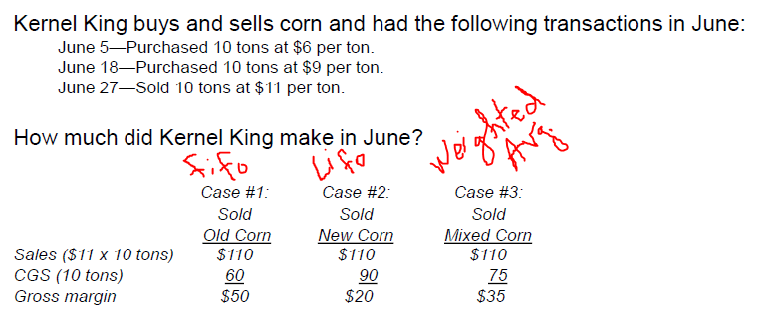Weighted average - Involves an average cost of all the purchases made, weighted by the number of units.
* Lower of Cost or Net Realizable Value (NRV)
  + Exception to cost principle.
  + Inclination of conservatism
    - inclination that companies have to report high profits and high assets. They like to inflate profits and assets. They typically don't understate them
  + Inventories are reported at the lower of the cost amount or the net realizable value, which is essentially a market value less any selling or disposal costs.
  + Carrying value - amount currently appearing on the balance sheet for inventory
  + Inventory is reported at less than cost when:
    - the future value of the inventory is in doubt (damaged, used, or obsolete)
    - it can be replaced new at a price less than the original cost.

### 5. Prepaid Expenses and Investments

#### Prepaid Expenses

* Expense
  + Prepaid Rent
  + Prepaid Insurance
* Transferred to expenses over time (when benefits are received)
* Because of the matching principle, we do not record these as expenses when the payment is made, but rather we spread the expenses over the periods that we're benefiting from these expenditures.

#### Investments

* Marketable Securities : " classified as trading or available for sale securities and are carried at fair value."
  + Short term investments in stock or bonds
  + Exception to cost principle: Stocks reported at Market (“Mark to market” because objective enough)
  + Bonds reported at Cost if intention is to hold to maturity; if not, reported at market

#### Long Term Investments

* Ownership of >50% of company’s stock
  + Consolidated Financial Statements – combines both companies financials as if they were one company.
  + Wholly owned subsidiary is 100% ownership.
* Ownership of 20% - 50% of company’s stock
  + Equity Method – does not recognize dividend – revenue only.
  + Significant Influence on payment on dividends can affect taxes.
* Ownership of < 20% of company’s stock
  + Same as for Short-term Investments
  + Report dividends when earned

### 6. Property, Plant & Equipment

* Fixed (Tangible) Assets
  + Land (no depreciation)
  + Buildings, Equipment, Land (depreciation)
  + Natural resources (depletion)
* Intangible Assets (Amortization)
* Depreciation, Depletion, Amortization: The process of cost allocation that assigns the cost of the asset to the periods benefited.
* Self-Constructed Assets: Cost includes all expenditures incurred to build the asset and make it ready for its intended use. (Matching Principle):
  + materials used to build the asset.
  + construction labor
  + share of the general company overhead.
  + capitalized interest – paid during construction – part of cost and asset.
* Expenditures on Existing Assets
  + Ordinary Expenditures: Typically benefit only the period in which they are made (repairs, maintenance, and minor improvements).
    - Expensed on income statement.
  + Capitalized Expenditures:
    - Benefit the company over several periods, not just the current one.
    - Capitalized on balance sheet.
    - Depreciated (Matching Prinicple)
    - Criteria: Increase productive life or capacity of the asset

### 7. Depreciation

* Determining Depreciation

1. Estimate of useful (intended) life.
2. Estimate of salvage (residual, scrap) value.
3. Depreciation totals the same. The methods determine when the depreciation is taken.

* 4 Methods of Depreciation

1. Straight-Line: The cost of the asset is allocated equally over the periods of an asset’s estimated useful life.
   1. Equal amount every year

Annual amount = (Cost – Salvage Value) / Useful Life

1. Units of output
   1. More output than more depreciation
2. Accelerated Depreciation - Sum-of-years-digits
   1. More in earlier years
   2. Most assets lose value and productivity earlier than later (such as cars)
   3. Follows matching principle.
   4. Later years often have more expenses for repairs.
3. Accelerated Depreciation - Double declining balance

* Balance Sheet
  + Accumulated Depreciation "Contra-asset" account
    - Deduction to arrive at the net book value
  + Equipment
  + Equipment (net) Book Value

#### Disposal of Assets

* Proceeds received for asset > Book Value Gain on sale on income statement (after operating called other)
* Proceeds received for asset < Book Value Loss on sale on income statement (after operating called other)

#### Natural Resources

* Depletion expense – like Units of Output method of depreciation

### 8. Intangible Assets

* Intangible assets - No physical substance but available resource for cocmpany such as a patent
* Definite life – amortization (depreciation) over min(economic life, legal life)
  + Patent legal life of 20 years
* Indefinite life

tested for impairment on annual basis. estimate of future cash flows is deemed by management to be less than the book value, then the asset is said to be impaired. The result is that the asset that has to be written down, and a loss is shown on the income statement.

* Goodwill - Purchase price of business or part of company – fair market value of net assets (if > 0)
  + Goodwill is the difference between purchase price and fair market value of net assets.
  + tested annually for impairment.
  + By net assets we mean the assets minus the liabilities

### 9. Research and Development

* Research and Development (R&D) generally must be expensed. (not matching principle).
  + Uncertainty on any benefits
* Software Development Costs: Special form of R&D which may be capitalized.
  + (economic viability can be determined more accurately and earlier than other R&D).
  + Capitalization begins when “technological feasibility” is reached.
  + Software costs incurred up to this point are expensed as R&D.
  + Technology Feasibility: Sufficient development progress has been made to ascertain that the software will meet its design specifications. (It will work.)
  + Capitalization ends and amortization begins when the product is available for general release.

### 10. Liabilities

#### Current Liabilities

* Debts and other obligations due within one year
* Examples of Current Liabilities:
  + Accounts payable
  + Wages payable
  + Income taxes payable
  + Accrued interest
  + Unearned revenues
* Payable and accrued are the same.
* unearned or deferred are also liabilities such as purchasing a gift card for a restaurant
* Working Capital = Current Assets – Current Liabilities (good to know if a business is viable

#### Contingent Liabilities

1. Probable & can be reasonably estimated.
   * 1. liability on balance sheet and disclosed
     2. Most common: Warranty liabilities. Expense on income statement.
2. Reasonably possible OR cannot be reasonably estimated.
   * 1. disclosure in notes
     2. Most common: Lawsuits
     3. Not recorded in balance sheet
3. Remote chance of liability no need to disclose even in notes.

#### Long-term Liabilities

* Examples
  + Notes payable.
  + Mortgages payable
  + Lease obligations
  + Deferred taxes
  + Bonds payable
  + Pension obligations
* Recording
  + Measurement and recording of long-term liabilities are based on the time value of money concept.
  + Present Value of Liability: Future amounts are discounted to obtain present value.
  + transferred to the current liability section of the balance sheet the year before they come due. They are reclassified as a current liability.
* Present Value of Liability: Future amounts are discounted to obtain present value because of inflation

#### Lease Obligations

* Operating Lease -- A simple short-term rental agreement. Expense on income statement.
* Capital Lease -- Asset and liability are recorded at present value of future payments on the balance sheet (i.e., treated as a purchase). Lenders look at liabilities on balance sheet. Lease look better on a balance sheet so lease term more than one year must be on balance sheet.

#### Deferred Taxes

* Results from timing differences between taxable income on Income Statement and taxable income for IRS.
* [Sometimes they are assets rather than liabilities]
* On income statement and IRS tax return just at different times.

### 11. Bonds

#### Bonds Payable

* Way to generate capital.
* Debt instruments sold to public & publicly traded (company must repay principle plus interest)
* Face Value = Amount to pay when bond matures (not necessarily the initial selling price of bond)
* Bond Discount and premiums
  + Stated interest rate < Market interest rate -> Discount price at purchase
  + Stated interest rate > Market interest rate -> Premium price at purchase
* Debenture – unsecured bond
* Balance Sheet Presentation: Face Value First

Balance Sheet Presentation of Discount:

Bonds Payable $100,000

Less: Discount on B/P 3,000

Bonds Payable (net) $97,000 -> carrying value

Balance Sheet Presentation of Premium:

Bonds Payable $100,000

Add: Premium on B/P 4,000

Bonds Payable (net) $104,000 -> carrying value

#### Convertible Bonds

* Can convert to stock at the option of the bondholder

#### Callable Bonds

* gain or loss on early retirement – to convert for change in interest
* Cash paid > Carrying value -> Loss on retirement net income
* Cash paid < Carrying value -> Gain on retirement net income
* “redeemable in whole or in part at our option”

#### Options to Raise Money for Company

##### Bonds

* Must repay bonds
* Must pay interest
* Interest reduces net income
* No dilution of ownership

##### Capital Stock

* No repayment of stock
* Need not pay dividends
* Dividends do not reduce net income (distributions of earnings)
* Dilutes ownership

### 12. Capital Stock

* Stockholders’ Equity = Paid-in-Capital + Retained Earnings
* #Authorized = #Issued (sold) + #Unissued
* #Issued = #Outstanding (voting rights and dividends) + #Treasury (bought back shares)
* outstanding shares: sold shares which have voting rights, receive dividends, and are used in determining earnings per share
* Earnings per Share (EPS) = Net Income (Net Loss) (minus preferred dividends) / # Outstanding Shares of Stock
* Paid-in-Capital: Accounts involving capital stock.
* Preferred Stock has preferences in:
  + Dividends are paid to preferred stock holders first
  + Liquidation are paid before common stock if company goes into bankruptcy
* Common Stock has main voting rights
* Par value : stated nominal value printed on the face of each share of the stock. Not market value but stock cannot be issued below this price
* Discount below par not allowed
* Premium allowed and usually labeled "Additional Paid-in-Capital”

#### Treasury Stock

* "Contra-equity” account (not an asset)
* Purchase of treasury stock is recorded at cost.
* No gain or loss reported on sales of treasury stock.

### 13. Cash Dividends

Question 23: Dividends Decreases Retained Earnings

Not reported on income statement but Net Income (Net Loss) (minus preferred dividends) is used to calculate EPS

#### Stockholders Equity

#### Dates

* Date of Declaration -> liability

When the board of directors votes to pay dividends, and it is at that time that the dividend payment becomes a liability of the corporation.

* Date of Record - Indicates who is to receive the dividends.
* Date of Payment - When the cash dividends are actually paid out by the company.

#### Preferred Stock Dividend Preferences

* Current Dividend Preference

Preferred stockholders get a % of total par. Common stockholders get remainder

Example:

Company has 10,000 shares of 5% dividend rate Preferred Stock, $10 par value

Current dividend preference = .05 x 10,000 x $10 = $5,000

If declared dividends are $4,000 then the preferred shareholders would get it all

If declared dividends are $5,500 then the preferred shareholders would get $5,000 and the common shareholders would get $500.

* Cumulative Dividend Preference

Preferred stockholder gets current dividend preference + dividends in arrears (missed dividends from past years). Common stockholder gets remainder after this is satisfied.

Example:

Company has 10,000 shares of 5% P. Stock, $10 par; no dividends paid for past 3 years prior to current year.

Cumulative Dividend Preference = $5,000 x 4 (3 arrears + current year) = $20,000

If declared dividends are $18,000 then the preferred shareholders would get it all and $2,000 would remain in arrears

If declared dividends are $25,000 then the preferred shareholders would get $20,000, and the common shareholders would get $5,000

* Dividend in arrears
  + Does not represent actual liabilities and are not recorded in the accounts and the balance sheet. No legal obligation to pay
  + Disclose in the notes to the financial statements.

### 14. Other Stockholders’ Equity Items

* Underlying accounting principles.
* Noncontrolling Interests: In consolidated balance sheets, the portion of owners’ equity not controlled by the parent company. For example owns 70% of company. 30% is noncontrolling interest. Must be reported in stockholder’s equity section.
* Stock-Based Compensation – must report as expense.

#### Stock Dividend

* Distribution of additional stock in proportion to current holdings
  + Effects of Stock Dividends
    - Increases # of shares outstanding
    - Transfers Retained Earnings to Paid-in-Capital
* Stock Dividends have no effect on:
  + Assets
  + Total stockholders' equity
  + % ownership of stock by shareholders

#### Stock Splits

* Increases # of shares
* Decreases par value per share -> No effect on accounts on balance sheet
* Reduces the market value per share of their stock
* Makes it more affordable for the everyday person to buy their stock.
* 2:1 stock doubles number of stock.
* Reduces the par value.

#### Reverse Stock splits

* Decreases # of shares
* Increases par value per share -> No effect on accounts on balance sheet
* Various stock exchanges have rules about the minimum trading price of the stock.
* Certain institutional investors have rules about the market value per share of stocks they invest in
* 1:2 decreases the number of stock
* Reduces par value
* Stockholders' Equity - OE for corporations
  + Capital Stock Capital - what the company received when selling shares of its stock
  + Retained Earnings – accumulated earnings less dividends. Dividends are a distribution of earnings, and that only occurs when the board of directors decides to distribute the earnings.
  + Common stock
  + Preferred stock

# EXAM I DUE 05/31 Financial Accounting

# Finance

## Week 3 05/31 – 06/06 Introduction to Financial Management and Investment Rules

The Finance module provides a general introduction to finance and capital structure. No matter what the manager’s role is in a corporation, an understanding of why and how financial decisions are made is essential. The module starts by describing the role of a financial manager in corporate decision making - emphasizing that the good decisions increase the value of the firm’s stock, and poor decisions decrease the value of the stock. Related to this is the concept of economic value creation (EVA) and the difference between economic profits and accounting profits. Students will then learn a central concept in finance – the time value of money; and how the time value of money is used as a critical component in capital budgeting - the decision-making process for accepting or rejecting projects. The student will learn how to calculate and apply important analytical decision rules such as net present value (NPV), internal rate of return (IRR), profitability index, and payback period. Importantly, the students will learn how these techniques are applied to approving projects and capital investments.

A dollar today is worth more than a dollar in one year because the dollar can be productively invested and will grow more than a dollar in one year. The opportunity cost of any investment is the return one could earn on the next best alternative. Waiting to receive the dollar until next year carries an opportunity cost equal to the return on the foregone investment. Because there are always productive opportunities for investment dollars, all investments have opportunity costs. We focus on capital budgeting, the decision-making process for accepting or rejecting projects. We first focus on different investment decision rules.

### Introduction- Part 1

Objectives

* To explain the role of a financial manager in corporate decision making and the value creation process.
* To explain the alternative investment rules that are used to select investment projects.
* To describe the process of estimating a project’s estimated cash flows, which are crucial inputs in the investment decision process.
* To explain how stocks are valued as the present value of all expected future dividends.
* To describe how risk is measured for financial instruments.
* To explain the relationship between risk and expected return using the Capital Asset Pricing Model.
* To estimate the weighted average cost of capital that determines the minimum rate of return that the corporation must earn on its invested capital to breakeven in economic terms.
* To estimate the value of a firm using the present value of projected free cash flows discounted at its weighted average cost of capital.
* To define the concepts of Economic Value Added and Market Value Added and explain how they relate to the goal of managing for value creation.

Top 5 companies are 23% of S&P 500 by market capitalization.

1. Apple
2. Microsoft
3. Amazon
4. Alphabet
5. Facebook

10% per year. 10,000. Want 20,000 to double. Interest rate * period = 72

72 = 10 * x -> 7.2 years would double money

72 rule

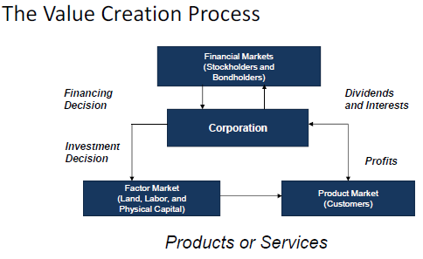

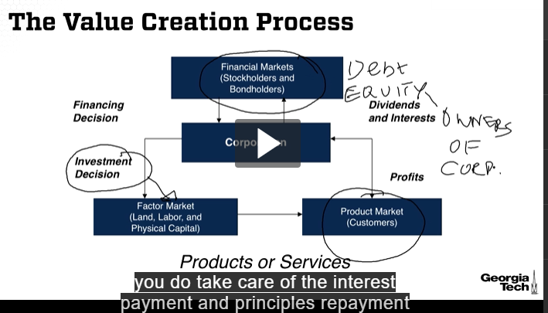

* 1.) Most important for a company to take care of the Customers – Product Market.
* Finance person focuses
  + investment decisions
  + how to access capital from financial markets in terms of debt and equity
* Equity holders are the owners of the corporation.
* 2.) Focus on making good investment decisions to create shareholder values by
  + increasing expected cash flows.
  + Decreasing the cost of capital.

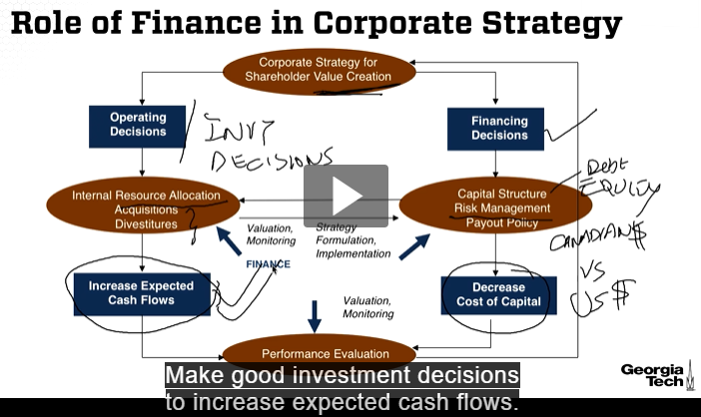

* Value Creation – purpose of the company is to provide value to the shareholders from investment decisions.
* Exchange risk management between different currencies.
* Decrease cost of capital to manage risk.

### Introduction- Part 2

Goal of Financial management:

Focus on maximizing on shareholder value.

#### Shareholder

* Shareholders are the owners of the corporation.
* The primary financial goal of any public corporation is to create economic value for its shareholders.
* Shareholders are residual claimants.
* Residual because they receive money only after:
  + suppliers have been paid.
  + wages to workers have been paid.
  + interest to bondholders have been paid.
  + taxes have been paid.
* If the shareholders are happy so are the stakeholders (suppliers, bond holders, workers…)
* Commitment to returning money to the shareholders.

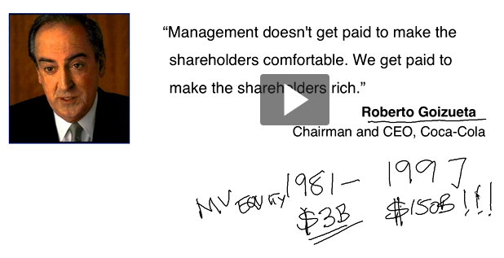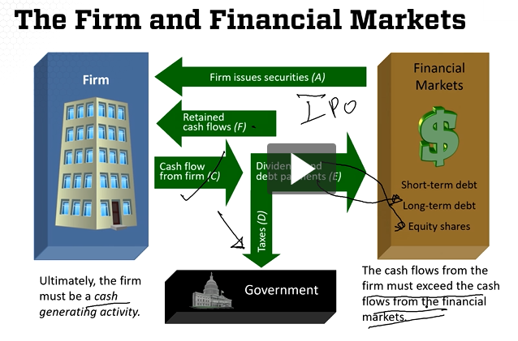

* Buffett – Berkshire Hathaway – 50 years – 1,000,000% return 1964- 2016

### Capital Investment Analysis- Part 1: Capital Investment Analysis – Introduction

#### Capital Budgeting

The process of determining exactly which assets to invest in and how much to invest is called capital budgeting decision or capital expenditure decision or capital investment decision.

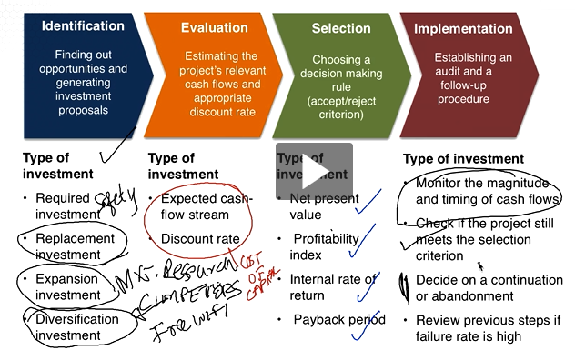

* Market research for expansive investment ideas, e.g. free wifi on Delta flight
* Most investments that corporations make are long-term in nature. We need a method for evaluating the financial benefits for these long-term investments.
* To do this we need to understand the concept of the time value of money.
  + A dollar today is worth more than a dollar in the future.
  + But how much more and what does it depend upon?
* Suppose your uncle offers a choice between receiving $1,000 today or $1,500 in five years. Which option would you accept if your opportunity cost of capital were r=10%?
  + Opportunity cost (r=10%) is the rate of return you sacrifice on the next best alternative

### Capital Investment Analysis- Part 2: Future and Present Values

#### Future Values

* The first method for deciding which option is best is to calculate the future value of investing the $1,000 payment at your opportunity cost of capital for 5 years.

Using an opportunity cost of capital r = 10%, the future value of your investment is calculated in the following table:

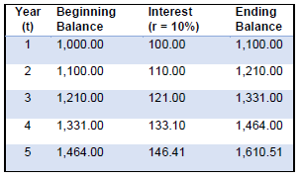

Because the amount you will have after 5 years is greater than the $1,000 today offered by your uncle, you are better off accepting the $1,000 today and investing it at r = 10% for the next 5 years

The general formula for finding the future value, FVt, of an investment of PV dollars today is:

FVt= PV x (1+r)t

* Principles of compounding interest
* Verify that the above formula works for PV = $1,000, r = 10% and t = 5 years.
* Use the FV formula to decide which option you should accept if r = 5%.
  + FV5 = $1000*(1 + 0.05) 5 = $1,276.28 -> then take offer of $1,500.

#### Future Values Excel

PV = $1,000 r = 10% t = 5 years

=FV(r, t, -PV) = $1,610.51 -> so don’t take $1,500 offer if you can get 10%

PV is always entered as a minus number.

#### Present Value Defined

* A more common method for evaluating your investment alternatives is to calculate present values.
* The present value is the amount of money you would need to invest today in order to duplicate some future dollar amount.

#### Present Value Equation

For example, how much money would you need to invest today to duplicate the $1,500 payment in 5 years offered to you uncle? Assume your opportunity cost of capital is r = 10%.

To answer this question, we can rearrange the formula for future values to arrive at a formula for present values:

FVt= PV x (1+r)t -> PV = = $931.38 -> You are better off accepting your uncle’s offer of $1,000 today.

* By accepting the $1,000 today you can do the following:
  + Invest $931.38 at r = 10% for 5 years. After 5 years it will be worth $1,500.
  + Enjoy a nice dinner at your favorite restaurant with the remaining $68.62.

Which option has the higher present value if your opportunity cost of capital is r = 5%?

PV = = $1,175.29 -> so don’t take the $1,000 today

#### Present Value Excel

PV = PV(years, percentage, -FV)

### Capital Investment Analysis-Part 3: Annuities and Use of Excel

* Zachary’s parents anticipate that a college education will cost $80,000 when he enters school in 18 years. They presently have $10,000 to invest.
  + =RATE(t,,PV,-FV) = 12.25%
* What rate of return must they earn to cover the cost of his education? Find Interest Rate
* Holly is saving to buy a $20,000 speedboat to take to the lake. She has $16,000 in an account paying 6 percent annual interest.
  + =NPER(r,,PV,-FV) = 3.83 years
* How long will it be before she will have enough to buy the boat? Find Number of periods

#### Present Value of an Annuity

* Skye just won first prize in the Colossal Lottery. He can choose between $50,000 in cash now, or its equivalent paid out in ten annual payments at an interest rate of 12%.
* What will his annual payments be under the second alternative?

PMT = = $8,849.21 = PMT(r,t,-PV)

#### Net Present Value

Most investments made by corporations are long-term in nature and generate cash flows for many years in the future. The most common method for evaluating these long-term investments as Net Present Value (NPV):

C0, C1, C2, ……. are cash flows at 0, 1, 2, etc. Assume C is known for now.

t is number of periods for useful life.

The NPV measures the value created for shareholders by the investment project.

* C0 is normally negative as the initial investment.
* If NPV > 0, then the project increases shareholder value and should be accepted.
* If NPV < 0, the project destroys shareholder value and should be rejected.
* If NPV = 0 then look at all cash flow projections and see if it makes sense to go ahead if it just breaks even

Because of the need to make large investments up front, the early cash flows are typically negative for most investment projects.

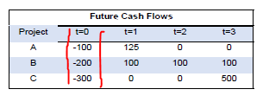Consider the following investment projects :

What is the net present value created by each of these investment projects for r=5%, r=15%, and r=25%?

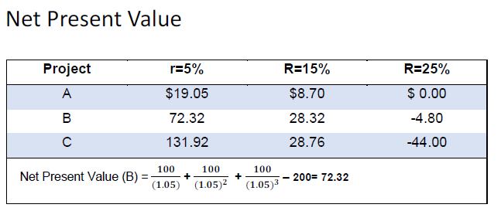

* If projects are independent and R=15%, accept all projects since they are all positive NPV
* If projects are mutually exclusive and R=15%, choose project C since it has the highest NPV, $28.76

### Capital Investment Analysis- Part 4: NPV, Payback, & IRR

* Independent: Acceptance or rejection is independent of the acceptance or rejection of other projects.
* Mutually Exclusive: Can accept “A” or you can accept “B” or you can reject both of them, but cannot accept both of them.
* A project’s payback period is the number of periods (usually measured in years) required for the sum of the project’s expected cash flows to equal its initial cash outlay. In other words, the payback period is the time it takes for a firm to recover its initial investment.
  + Project A : 1 year
  + Project B: 2 years
  + Project C: 3 years
  + Company has a business rule for payback if independent – problematic so payback period not good metric.
  + For mutually exclusive, use lowest time, Project A. Penalizes long term so not a good metric.
  + Does not take into account time value of money.
  + Good to break a tie

#### Internal Rate of Return (IRR)

* A project’s internal rate of return (IRR) is the discount rate that makes the net present value (NPV) of the project equal to zero:
* Accept the project if IRR is greater than the cost of capital if independent.
* Accept the project with highest IRR if mutually exclusive.
* IRR == rate of return == discount rate

### Capital Investment Analysis- Part 5: Profitability Index and Problems with IRR

#### NPV IS THE BEST METRIC

#### Profitability Index or Benefit Cost Ratio

* The present value of an investment’s future cash flows divided by its initial cost. Also called benefit/cost ratio.
* PI = (C0 + NPV)/C0
* PI > 1 then accept the project if independent.
* Highest PI if mutually exclusive.

#### Problems with IRR

* Multiple IRRs Can Exist
* The Scale Problem
* The Timing Problem

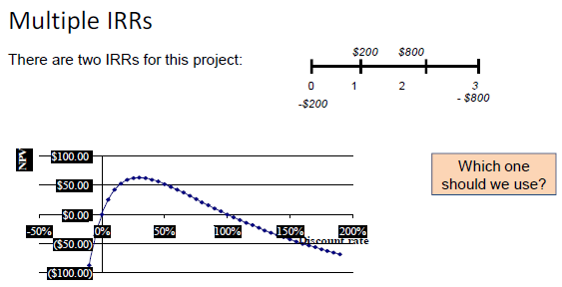

* IRR Negative cash flow at beginning and the end of a project.
* Changes in the cash flow sign gives this
* The Scale Problem
  + Would you rather make 100% or 50% on your investments?
  + What if the 100% return is on a $1 investment, while the 50% return is on a $1,000 investment?
  + This fails the IRR because of 100% return of $1 versus 50% return of $500.
* The Timing Problem

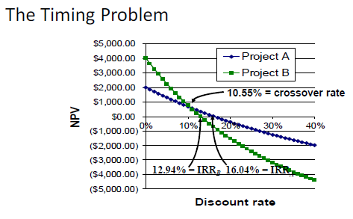

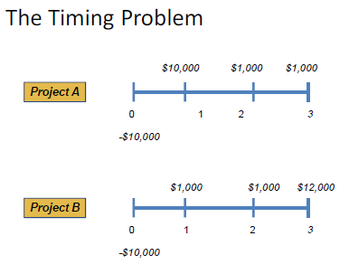

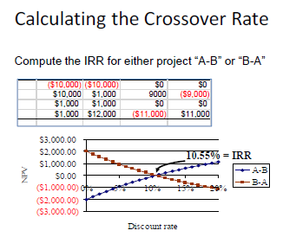

### Capital Investment Analysis- Part 6: NPV vs IRR

* NPV and IRR will generally give the same decision. Exceptions:
  + Non-conventional cash flows – cash flow signs change more than once.
  + Mutually exclusive projects
    - Initial investments are substantially different.
    - Timing of cash flows is substantially different.
* Remove first year’s costs for NPV for comparison
* PV is only for equal payments
* PI is the present value of future cash flows divided by the initial cost of the project. If the PI exceeds 1 then the project will create economic value. If less than 1 the project will destroy value.
* Comparing Analytical Methods
* Discounted value for year 2 its 470,000/((1 +.14)(1+.14))
* IRR for homework answers:
  + irr 12.36% 14.88% 10.94%
  + npv $84,724.43 $82,796.45 -$1544
  + Take positive NPV Cliff hanger and The Chainsaw if unlimited $$
  + Only $3M then only cliffhanger
  + Shortest payback period chainsaw
  + Irr is fine for independent projects
  + Return on investment accounting measure net income / capital ignores time value of money - bad

NPV is for varying payment amounts (for annuity)

Payback is the period is the number of periods (usually measured in years) required for the sum of the project’s expected cash flows to equal its initial cash outlay. They payback period is the time for it takes for a firm to recover its initial investment.

Should be < 2 years.

* Making capital investments
  + Assess and evaluate proposals for capital investments. Cash inflow/outflow.
    - net present value (NPV)
    - internal rate of return (IRR)
    - payback period
    - profitability
* firm’s cost of capital
  + Weighted Average Cost of Capital (WACC)
* Decision points
  + Internal rate of return (IRR) > WACC than invest creates economic value
  + Internal rate of return (IRR) < WACC than do not invest.
* Valuation – current value of company
  + Net present value (NPV)
  + Stock Market
* 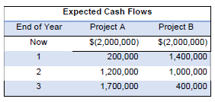Two projects have the expected cash flows shown below. The projects have similar risk characteristics and their cost of capital is 10%

1. Calculate the NPV of each project. According to the NPV rule, which project should be accepted if they are independent? If they are mutually exclusive?
2. Calculate the payback period of each project. If the two projects are mutually exclusive, which project should be accepted?
3. Calculate the IRR of each project. Which project should be accepted if they are independent? If they are mutually exclusive?
4. Calculate the profitability index of each project. Which project should be accepted if they are independent? If they are mutually exclusive?
5. Based on your previous answers, which criterion leads to the best investment decision if the projects are independent? If they are mutually exclusive?

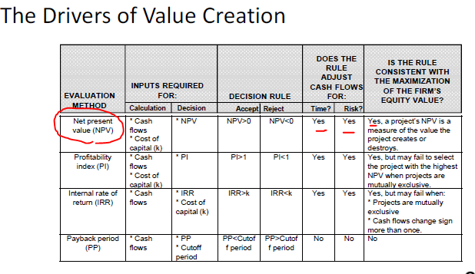

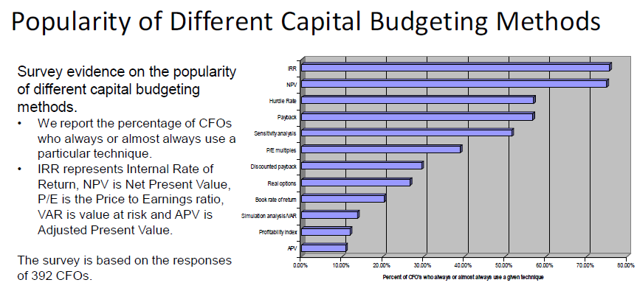

## Week 4 06/07 -06/13 Evaluating Investment Opportunities and Stock Valuation

We focus on estimating an investment’s relevant cash flows. Determinants of relevant cash flows demand business judgment and perspective. The role of sensitivity analysis and simulation is discussed in the context of NPV analysis. These methods are illustrated through several examples and a case. We also cover the basics of stock valuation using discounted dividend models.

### Capital Investment Analysis- Part 7: Relevant Cash Flows

* Principle 1: Record cash flows when the money actually moves, not when the accountant using accrual concepts says they occur.
* Principle 2: Imagine two worlds, one in which the investment is made and one in which it is rejected. All cash

flows that are different in these two worlds are relevant to the decision, and those that are the same are irrelevant.

#### Example: Microdyne

Times are tough for Microdyne. If it engages in a new, year long promotional campaign costing $10 million, its annual

after-tax cash flow over the next five years will be only $100,000 after tax cash flow. If it does not undertake the campaign, it expects its after-tax cash flow to be minus $3 million annually for the same period. Assuming that the company has decided to stay in its chosen business, is this campaign worthwhile when the discount rate is 10%. Why or why not?

True benefit = -3M + 100k = 3.1M

NPV = -10 + 3.1/1.1 + 3.1/(1.1)2 + 3.1/(1.1)3 + 3.1/(1.1)4 + 3.1/(1.1)5 = 10 + 2.818 + 2.562 + 2.329 + 2.117 + 1.95 = $1.75M

Accept the project!! > NPV > $0

#### Treatment of Costs

* Sunk Costs: Not relevant for present decision such as marketing. Already spent and cannot change project cash flow such as Test Marketing Costs: Marketing research expenses expended.
* Erosion Costs: Cash flow transferred to a new project from sales and customers of other products of the firm.
* Opportunity Costs: Lost revenues from alternative uses of the asset such as a lease revenue

#### Cash Flows

Depreciation: It is a non-cash expense. Add depreciation back to income after tax to calculate the investment’s after-tax cash flow. (ATCF)

ATCF = (Revenue - Costs - Depreciation) (1-Tax) + Depreciation = (R - C) (1 - Tax) + D (Tax)

Working Capital: Changes in the that are the result of an investment decision are relevant to the decision. At the beginning of the project life, working capital would be treated as cash outflows. At the end of project life, working capital would be treated as cash inflows. Such as stocking new store with inventory.

* Factors to Consider when making cash flow estimates.
  + Price,volume
    - competition from existing products
    - Competition from technological advances
    - Values to customer
  + Variable costs
    - Labor
    - Material
    - Energy
  + Capital expenditure.
    - Property
    - Plant & Equipment
  + Working Capital
    - Inventory
    - Accounts receivable
    - Accounts payable

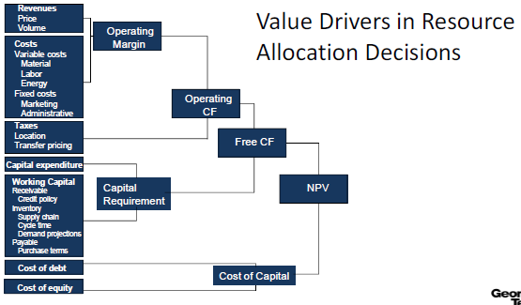

Free Cash Flow = Operating Cash Flow – Capital Requirement used for NPV

### TO DO Capital Investment Analysis- Part 8: Cash Flow Examples

#### Example: Baffle Bag and Box Company

One year ago, Baffle Bag and Box Company (BB&B) purchased a new folder for $11,000. The company now finds a new box folder is available that may offer significant advantages. The new machine can be purchased for $15,000, has an economic life of 10 years, and has no salvage value. It is expected that the new machine will produce a gross margin of

$4,000 per year, so that, using straight-line depreciation, the annual taxable income will be $2,500.

The current machine is expected to produce a gross margin of $2,000 per year, and, assuming a total economic life of 11 years and straight line depreciation, a profit before taxes of $1,000. The current market value of the old machine is $5,000. BB&B’s tax rate is 45%, and its cost of capital after tax is 10 percent.

Ignore possible capital gain taxes and assuming zero salvage values at the end of the machines’ economic lives, should BB&B replace its year-old box folder?

|  |  |  |
| --- | --- | --- |
|  | **Old Machine** | **New Machine** |
| Gross | $2,000 | $4,000 |
| - Depreciation | $1,000 | $1,500 |
|  |  |  |
| Profit before tax | $1,000 | $2,500 |
| tax (45%) | $450 | $1,125 |
| Profit after tax | $550 | $1,375 |
| + Depreciation | $1,000 | $1,500 |
|  |  |  |
| After-tax cash flow | $1,550 | $2,875 |
| New Operating Cash Flow | =2875 - 1150 | $1,325 |
| NPV | =NPV(rate,10 : $1325 payments) + initial investment | -$1,858 |

Cost of capital = discount rate = r

Why do we subtract depreciation only to add it back? In books but not a cash difference. It’s a non-cash item.

Using With-Without Principle: $2875 - $1550 = $1325 for 10 years incremental

Initial Cash flow = Cost of new machine less Proceeds from sale of old machine

15,000 – 5,000 = 10,000

Operating cash flow = $1,325 for 10 years

Terminal cash flow = 0

NPV = -10,000 + (1,325/1.1) +(1,325/1.12)+............. +(1,325/1.110) = -$1,858

DO NOT REPLACE because -$1,858 . If a buyer can purchase the old machine then this may make sense to replace.

#### TO DO Example: Auger Biotech

Times are tough to Auger Biotech. Having raised $85 million in an initial public offering of its stock early in the year, the company is poised to launch its product. If Auger engages in a promotional campaign costing $60 million this year, its

annual after-tax cash flow over the next five years will be only $700,000. If it does not undertake the campaign, it expects its after-tax cash flow to be minus $18 million annually for the same period.

Initial Cash flow = Cost of new campaign = $60 Million

15,000 – 5,000 = 10,000

Assuming the company has decided to stay in its chosen business, is this campaign worthwhile when the discount rate is 10 percent? Why or why not?

|  |  |  |
| --- | --- | --- |
|  | **Old Product** | **New Product** |
| Gross | -$18 M | $ 0.7 M |
| - Depreciation | 0 | 0 |
|  |  |  |
| Profit before tax | -$18 M | $ 700,000 |
| tax (45%) | 0 | $315,000 |
| Profit after tax | 0 | $385,000 |
| + Depreciation | 0 | 0 |
|  |  |  |
| After-tax cash flow | -$18 M | $385,000 |
| New Operating Cash Flow | =385,000 – (-18 M) | $18,385,000 |
| NPV | =NPV(rate,10 : $1325 payments) + initial investment | $52,967,866 |

NPV > SO LAUNCH NEW PRODUCT

#### TO DO Example: Caffe Vita Coffee Roasting Co.

One year ago, Caffe Vita Coffee Roasting Co. (CVCRC) purchased three small batch coffee roasters for $3.3 million. The company now finds that new roasters are available that offer significant advantages. The new roasters can be purchased for $4.5 million, have an economic life of 10 years, and have no salvage value. It is expected that the new roasters will produce a gross margin of $1.2 million per year, so that, using straight-line depreciation, the annual taxable income will be $750,000.

The current roasters are expected to produce a gross profit of $600,000 per year and, assuming a total economic life of 11 years and straight-line depreciation, a profit before tax of $300,000. The current market value of the old roasters is $1.5 million. CVCRC’s tax rate is 45 percent, and its cost of capital after tax is 10 percent.

|  |  |  |
| --- | --- | --- |
|  | **Old Coffee Roasters** | **New Coffee Roasters** |
| Gross | $3,300,000 | $4,500,000 |
| - Depreciation | $300,000 | $450,000 |
|  |  |  |
| Profit before tax | $300,000 | $750,000 |
| tax (45%) | $135,000 | $337,500 |
| Profit after tax | $165,000 | $412,500 |
| + Depreciation | $300,000 | $450,000 |
|  |  |  |
| After-tax cash flow | $465,000 | $862,500 |
| New Operating Cash Flow | =2875 - 1150 | $397,500 |
| NPV | =NPV(rate,10 : $1325 payments) + initial investment | -$710,788 |

NPV < 0 SO DON’T BUY NEW ROASTERS

### Capital Investment Analysis- Part 9: Inflation, Sensitivity, and Simulation Analysis

#### Inflation and Returns

Example:

We have $1000, and Diet Coke cost $2.00/six pack. We can buy 500 six packs. Suppose the rate of inflation is 5%, so that the price rises to $2.10 in one year. We invest the $1000, and it grows to $1100 in one year. What’s our return in dollars? In six packs?

* Dollars. Our return is: ($1100 - $1000)/$1000 = $100/$1000 = 10% (nominal rate of return)
* Six packs. We can buy $1100/$2.10 = 523.81 six packs, so our return is:

(523.81 - 500)/500 = 23.81/500 = 4.76% (real return)

#### Real versus Nominal Returns

* Nominal return – **R ~ r + h** - is the percentage change in the amount of money you have. Real + Inflation
* Real return - **r** - is the percentage change in the amount of stuff you can buy which accounts for inflation -**h**

#### Fisher Effect

1 + R = (1 + r) x (1 + h)

From above, the real return is 4.76%; the nominal return is 10%, and the inflation rate is 5%:

(1 + R) = 1.10 (1 + r) x (1 + h) = 1.0476 x 1.05 = 1.10 Approximately R = r+h

#### Capital Budgeting & Inflation

* BE CONSISTENT: Express cash flows in real terms and discount them at the real interest rate or
* PREFERED: Convert real cash flows to nominal cash flows by allowing them to grow at rate of inflation and discount them at the nominal rate. Cost of capital is in expressed in nominal terms
* Issue is important when dealing with
  + Long horizons
  + High inflationary times
* Depreciation always expressed in nominal terms.

#### Sensitivity Analysis

* Target Market Share changes
* Cost Overrun with cost of goods sold
* Inflation
* Competition on market share
* Discount Rate
* Valuable Options – e.g. Home Depot expanding to new countries

#### Example: Home Depot Capital Investment

* Home Depot is considering a new store with the following characteristics:
  + Initial investment of $20 million on 100,000 square feet store.
  + The HD plans to borrow $5 million, at an interest rate of 5.8%, using a 10-year term loan.
  + The store will have a life span of 10 years.
  + Estimated salvage value of $ 7.5 million at the end of 10 years.
  + Estimated sales $40 million in the first and expected to grow at 5%.
  + The pre-tax operating margin, at the store prior to depreciation, is expected to be 10% for the entire period.
  + The after-tax operating income and depreciation is given in the next page.
  + The net working capital is expected to be 8% of revenues and is expected to be entirely salvageable at the end of ten years.
  + Working capital investments are assumed to be made at the beginning of each year.
  + The cost of capital is 9.78%.
* The net present value of free cash flows to Equity discounted at the cost of equity of 9.78% is $4,101,613 The internal rate of return is 13.53% so ACCEPT THE PROJECT

#### Simulation

##### Step 1 - Identify each key variable and the probability distribution associated with it.

Variable

Base Case Revenues $ 30 million or $300 per square foot

Growth rate = 5%

Operating Margin = 10% WC = 10% of revenues

Revenues $ 200 per square foot to $400 per square foot

Growth 0 to 12%

Operating Margin 2 % to 20%

Working Capital 0 to 20%

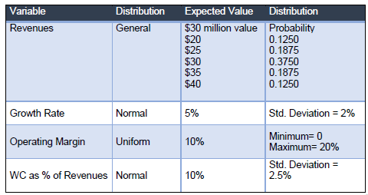

##### Step 2 - Draw one outcome for each variable. Using @RISK software

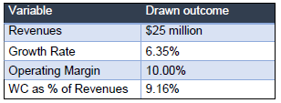

##### Step 3 - Estimate NPV and IRR.

* NPV = -13,423
* IRR = 12.48%

##### Step 4 - Repeat steps (2) and (3) 5,000 times. Compute the summary statistics as output.

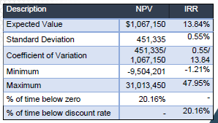Do the project if willing to take 20% risk below zero.

##### Step 5: Use the distribution of NPV to answer the questions:

* What is the likelihood that this will be a bad project?
* What is the worst case and best-case scenarios?
* Can you try to build linkages in the simulations?

#### Summary

* Net Present Value is the most preferred technique.
* Capital budgeting must be done on an incremental basis. This means that sunk costs must be ignored, while opportunity costs and side effects must be considered.
* Inflation must be correctly handled. One approach is to express both cash flows and the discount rate in nominal terms. The other approach is to express both cash flow and discount rate in real terms.
* Uncertainty in the forecasts can be addressed by conducting sensitivity analysis or simulation.

### Stock Valuation- Part 1: Introduction and Constant Growth Valuation Model

#### Objectives

* Explain how stock prices depend on future dividends and dividend growth
* Compute stock prices using the dividend growth model.
* Explain how growth opportunities affect stock values.
* Describe the PE ratio (price earnings)

#### PV of Common Stocks

The value of any asset is the present value of its expected future cash flows.

Stock ownership produces cash flows from:

* Dividends
* Capital Gains

Valuation of Different Types of Stocks

* Zero Growth

Dividends **Div** will remain at the same level forever. Since future cash flows are constant, the value of a zero-growth stock is the present value of a perpetuity. **R** is the Nominal return: P0 =

Preferred stock of a company is an example.

R is always given 4:40 .

* Constant Growth

Assume that dividends will grow at a constant rate, g, growth rate, forever. Since future cash flows grow at a constant rate forever, the value of a constant growth stock is the present value of a growing perpetuity:

Div1=Div0(1+g) Div2 = Div1(1+g) = Div0(1+g)2 -> P0 =

1. Next dividend
2. If g = 0 then becomes zero growth case 1
3. Undefined if g > R

* Differential Growth – “real world”. Use growth until constant growth .

#### Example Constant Growth

P0 is price at time zero.

Suppose Big D, Inc., just paid a dividend of $0.50. It is expected to increase its dividend by 2% per year. If the market requires a return of 15% on assets of this risk level, how much should the stock be selling for?

P0 = 0.50(1+0.02) / (0.15 - 0.02) = $3.92

### Stock Valuation- Part 2: Differential Growth Model and Estimation of Parameters

#### Differential Growth

Assume that dividends will grow at different rates in the foreseeable future and then will grow at a constant rate thereafter.

To value a Differential Growth Stock, we need to:

* Estimate future dividends in the foreseeable future.
* Estimate the future stock price when the stock becomes a Constant Growth Stock (Case 2).
* Compute the total present value of the estimated future dividends and future stock price at the appropriate discount rate.

#### Differential Growth Example

A common stock just paid a dividend of $2. The dividend is expected to grow at 8% for 3 years, then it will grow at 4% in perpetuity. What is the stock worth? The discount rate is 12%.

Generate Timeline:

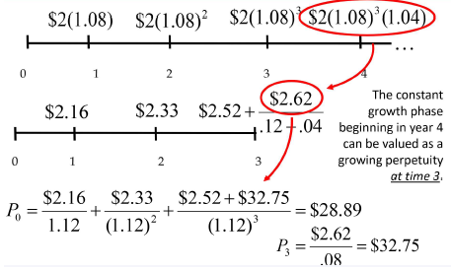

P0 = 2.00(1+0.08) / (0.12 - 0.02) = $3.92

P0 = P3 = $2*(1.08)4/(0.12 – 0.04) = $32.75

#### Estimates of Parameters.

The value of a firm depends upon its growth rate, g, and its discount rate, R. Where does g come from?

* g = Retention ratio × Return on retained earnings
* Retention Ratio = 1 – (Dividend per share/Earnings per share)
* Retained Earnings = Net Income / Return on Equity
* A Retention Ratio of 1 means Retains all of income, no dividends.

Where does R come from?

The discount rate can be broken into two parts.

* The dividend yield.
* The growth rate (in dividends).
* P0 = R=

In practice, there is a great deal of estimation error involved in estimating R. Do sensitivity analysis.

#### Growth Opportunities

Growth opportunities are opportunities to invest in positive NPV projects. The value of a firm can be conceptualized as the sum of the value of a firm that pays out 100% of its earnings as dividends plus the net present value of the growth opportunities.

A cash cow pays all earnings as dividends and does not grow. For a cash cow:

#### NPVGO Model: Example

Consider a firm that has forecasted EPS of $5, a discount rate of 16%, and is currently priced at $75 per share. We can calculate the value of the firm as a cash cow.

= 5/16 = $31.25

So, NPVGO must be: $75 - $31.25 = $43.75 comes from investors expecting growth opportunities.

An increase in the retention rate will:

* Reduce the dividend paid to shareholders.
* Increase the firm’s growth rate.

These have offsetting influences on stock price. Which one dominates?

* If Return on equity>R, then increased retention increases firm value since reinvested capital earns more than the cost of capital. This creates value for shareholders with positive net present value (NPV).
* Comparables are used to value companies based primarily on multiples.
* Common multiples include:
* EQUITY: P multiples. Price-to-Earnings Ratios - The price-earnings ratio is calculated as the current stock price divided by annual EPS. The Wall Street Journal uses last 4 quarter’s earnings. Estimates value of business. NPVGO is the growth opportunity.

P/E Ratio = &

* PE ratio is positively related to growth opportunities and negatively related to risk (R)
* VALUE: Enterprise Value Ratios
  + EV = market value of equity + market value of debt – cash
  + Net debt = market value of debt – cash
  + Like PE, we compare the value to a measure of earnings. From a firm level, this is EBITDA, or earnings before interest, taxes, depreciation, and amortization.
  + EBITDA represents a measure of total firm cash flow
  + The Enterprise Value Ratio = EV / EBITDA

#### Example EV/EBITDA

FFDP Corp. has yearly sales of $48 million and costs of $15 million. The company’s balance sheet shows debt of $64 million and cash of $23 million. There are 1.95 million shares outstanding and the industry EV/EBITDA multiple is 6.4.

* What is the company’s enterprise value?
* What is the stock price per share?

EBITDA = $48 M - $15 M = $33 M

Enterprise Value = $33 M * (6.4) = $211.2 M

Equity Value = Equity Value + Cash – Debt = $211.2 + 23 – 64 = $ 170.2 M

Stock Price = EV/#shares = $170.2M/1.94M = $87.28

### Stock Valuation- Part 3: Stock Valuation Numerical Examples and Summary

#### Example: Nonconstant Growth

Storico Co. just paid (Div0 )a dividend of $3.40 per share. The company will increase its dividend by 20 percent next year and will then reduce its dividend growth rate by 5 percentage points per year until it reaches the industry average of 5 percent dividend growth, after which the company will keep a constant growth rate forever.

* If the required return on Storico stock is 13 percent, what will a share of stock sell for today?

Draw Timeline: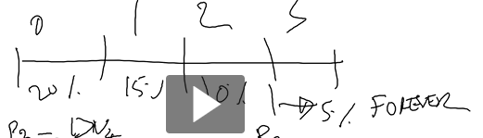

P3=Div4/(r-g) =

P0 =

#### Stock Valuation Summary

A stock can be valued by discounting its dividends. There are three cases:

1. Zero growth in dividends: P0 = Div/R
2. Constant growth in dividends: P0 =
3. Differential growth in dividends: P =

The growth rate can be estimated as:

g = Retention ratio × Return on retained earnings

An alternative method of valuing a stock was presented, the NPVGO values a stock as the sum of its “cash cow” value

plus the present value of growth opportunities.

## Video Conference 6/9

* 10 treasury bond is inversely related to the stock price.
* NPV For Projects With Different Timelines
  + Repeat investments and returns over time
  + Take the lowest common multiple to
* Week 4 Self-Assessment Supplemental Questions has useful life 3 and 5 years, they both repeat 15 times right? YES. 15 years is the lowest common multiple.
* Company only has one discount rate – in case of multiple IRR with non-conventional cash flow such as for mining where expense for restoration and a result of two sign changes. Use NPV rules instead as a problem with IRR. Excel will not give both results – only first IRR value.
* Non-conventional - A cash flow that has more than one sign change (negative to positive, or positive to negative). The most common is to have a inital investment (which is negative) followed by positive cash flows such as negative to positive then positive to negative
* IRR does not take into account the scale of the investment - $1 versus $100
* Timing Problem Crossover Rate with timing issues will cause IRR incorrect choice if < crossover rate for mutually exclusive projects. If independent not a problem. MS Excel will only give first IRR value – not second one.
  + NPV profile with different discount rates for each project
  + Two projects NPV_A = NPV_B
  + Construct New project B-A and find its IRR
  + Cost of capital is 10% and B&A are independent so choose both. IRR(a) = 16.04% and IRR(b) = 12.94%
  + For mutual exclusive choose B because it has a higher NPV. 5%. But IRR would choose A. When the IRR is less than the crossover point then get the incorrect answer.
  + Once > crossover rate of 10.55% then both give correct answer
  + Problem with 0 to crossover rate
  + Cost of capital is 33% then none would work. No A and No B. IRR is less than 33% so IRR would not choose either project. IRR(a) < 33%
* Estimate Cash Flows
  + Baffle Bags

## Week 5 06/14 – 06/20 Risk, Return, Cost of Capital, and Firm Valuation

We introduce the notion of risk. We explain the distinction between diversifiable and systematic risk. We discuss the capital asset pricing model (CAPM) that establishes a relation between risk and expected return. We estimate the cost of equity using CAPM. We then introduce a method to estimate the cost of debt. We then develop the concept of weighted average cost of capital (WACC). One interpretation of WACC is that it is the overall expected rate of return the firm must earn on its existing assets to maintain its value. We then use the firm’s WACC as our discount rate and value the firm by using the discounted projected free cash flows. This lesson concludes by linking NPV, economic value added (EVA) and market value added (MVA) concepts. Students will also learn how WACC, when used as the discount rate in a NPV calculation, can be used to determine if the firm is creating or destroying economic value when investing in a project.

#### Objectives

Describe how risk is measured for financial instruments.

* Explain the relation between risk and expected return using Capital Asset Pricing Model (CAPM).
* Estimate the weighted average cost of capital (WACC) that determines the minimum rate of return that the corporation must earn on its invested capital to breakeven in economic terms.

### Cost of Capital- Part 1: Introduction and Cost of Debt

#### Cost of Capital

* The cost of capital is the rate of return the corporation must earn on its invested capital in order to compensate for the time value of money and risk.
* The cost of capital is a weighted-average of the cost of debt and the cost of equity. This is called the Weighted Average Cost of Capital (WACC).
* Capital = Debt financing + Equity Financing
* Debt is tax deductible so tax rate is factored in

WACC = Cost of Debt x (1-Tax Rate) x (Debt/(Debt+Equity)) + Cost of Equity x (Equity/(Debt+Equity))

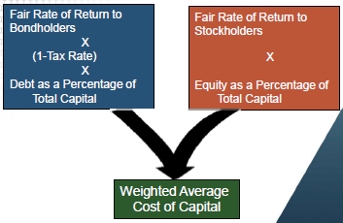

#### Capital Structure Decision

There are many factors that influence a company’s choice of capital structure. However, the four most important factors that influence this decision are:

* Taxes
* Stability of cash flows and earnings
* Financial and operating flexibility
* Type of assets (buildings, land, etc.)

In general, companies in mature industries with fairly stable cash flows, tangible assets, and few investment opportunities can support higher debt levels

Companies in growth industries with significant investment opportunities, high variable cash flows and intangible assets can support much lower debt levels.

Do not want bonds to be downgraded so don’t take on too much debt.

#### Cost of Debt

* The cost of debt is the rate of interest that the firm would pay on any new bank borrowing or bond issue.
* The cost of debt depends upon a number of factors, but the two most important factors are:
  + Current interest rate on US Treasury bonds with the same maturity
  + Default risk
  + Treasury Bond Rate is risk free

Cost of Debt = Treasury Bond Rate + Default Premium (dynamic)

100 Basis points = 1%. www.finra.org

#### Bond Ratings

|  |  |  |  |  |  |  |
| --- | --- | --- | --- | --- | --- | --- |
| **Quality** | **Moody** | **B** | **S&P** | **Spread** | **Basis/100** | **Moody's Debt Rating Description** |
| High – Exxon and ADP. Not Many companies | Aaa |  | AAA | 82 | 0.82% | Judged to be of the best quality. They carry the smallest degree of investment risk and are generally referred to as “gilt edged.” Interest payments are protected by a large or exceptionally stable margin and principle is secure. While the various protective elements are likely to change, such changes as can be visualized are most unlikely to impair the fundamentally strong position of such issues. |
| High | Aa | A1 | AA | 84 | 0.84% | Judged to be of high quality by all standards. Together with the Aaa group they comprise the high-grade bonds. They are rated lower than the best bonds because margins of protection may not be as large as in Aaa securities or fluctuation of protective elements amplitude or there may be other elements present which make the long term risk appear to be somewhat larger than the Aaa securities. may be of greater |
| Medium | A | A2 | A | 111 | 1.11% | Possess many favorable investment attributes and are considered as upper medium-grade obligations. Factors giving security to principal and interest are considered adequate, but elements may be present which suggest a susceptibility to impairment sometime in the future. |
| Medium | Baa | Baa3 | BBB | 183 | 1.83% | Considered as medium-grade obligations. Interest payments and principle security appear adequate for the present but certain protective elements may be lacking or may be characteristically unreliable over any great length of time. Such bonds lack outstanding investment characteristics and in fact have speculative characteristics as well. |
| Junk Bond. Speculative Grade: Low Quality | Ba | Ba1 | BB | 323 | 3.23% | Judged to have speculative elements; their future cannot be considered as well-assured. Often the protection of interest and principal payments may be very moderate, and thereby not very well safeguarded during both good and bad times over the future. Uncertainty of position characterizes bonds in this class. |
| Junk Bond. Speculative Grade: Low Quality | B |  | B | 505 | 5.05% | Generally lack characteristics of the desirable investment. Assurance of interest and principal payments or of maintenance of other terms of the contract over any long period of time may be small. |
| Lowest | Caa |  | CCC | 1219 | 12.19% | Poor standing. Such issues may be in default or there may be present elements of danger with respect to principal and interest. |
| Lowest | Ca |  | CC |  |  | Represent obligations which are speculative in a high degree. Such issues are often in default or have other marked shortcomings. |
| Lowest | C |  | C |  |  | Lowest rated class of bonds, and issues so rated can be regarded as having extremely poor prospects of ever attaining any real investment standing. |

#### Example

Home Depot’s outstanding public debt is rated A2 by Moody’s. Use the Treasury Yield Curve and the Corporate Default Spreads to estimate the cost of debt for Home Depot. Make the appropriate calculations assuming a 10-year maturity.

### ?? A2 == A ? How do we know? Treasury Yield (10-Year Bond) 2.7% + Default Spread 1.11% = 3.81%

Pre-Tax Cost of Debt 3.81%

And one of the very good sources for bond ratings is the finra.org website. For Home Depot, I went and checked, and they are rated as A2 by the Moody's. So what I'm going to do is from the previous slide, tag on 1.11% to estimate Home Depot's cost of debt as 3.81%.

### Cost of Capital- Part 2: Cost of Equity and Beta

#### Cost of Equity

The cost of equity is an opportunity cost. It is the rate of return that stockholders expect

the firm to earn on its equity capital. The cost of equity depends upon a number of factors but the two most important factors are:

* Current interest rate on long-term U.S. Treasury bonds.
* Risk of equity which is the cost of debt equity

Cost of equity = Treasury Bond Rate + Risk Premium

#### Reducing Risk Through Diversification

Consider an oil company with $1,000 cash that has the opportunity to invest in the development of an oil field. If the company invests in the development of the oil field, there is a 50% chance that the oil field will be dry and a 50% chance that will produce 40 barrels of oil over next year. However, the price at which oil can be sold is uncertain and depends upon the overall economic conditions. The table below summarizes the possible outcomes.

Four scenarios with equal probabilities of 25%

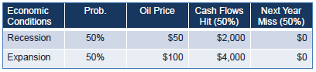

Expected Cash Flow = .25 ($2,000) + .25 ($4,000) + .25 ($ 0) + .25 ($ 0) = $1,500

Expected Return = (1500-1000)/1000 = 50%

Standard Deviation = 165.8%

Now suppose there are 1000 oil companies, all with same opportunity to invest $1,000 in the development of an oil field. The success or failure of the oil fields are independent of one another. What is the expected return and standard deviation of the entire portfolio of 1000 companies?

* 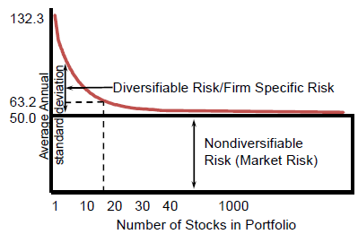The standard deviation reduces to the market risk as number of companies increases.
* 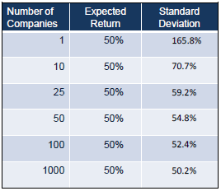500 stocks in S&P 500 companies is diversification for lower deviation.
* Risk does not go away but it is minimized with firm specific risks.
* In the limit, as the number of companies gets large, the standard deviation of the portfolio approaches the average covariance between companies.
* Portfolio of stocks reduces risk

#### Firm-Specific Risk – Reduced with Portfolio

Firm-specific risk factors are events that are unique to a single firm or industry. They include such things as:

* A firm’s CEO suddenly gets killed.
* A company loses a major lawsuit.
* A wildcat strike in one of the firm’s plants.
* An unexpected entry of a competitor.

#### Market Risk – Exists with Portfolio

Market risk factors are macroeconomic events that affect all firms to some degree. They include such things as:

An unexpected increase in long-term interest rates.

* Recession
* Changes in monetary or fiscal policy.
* U.S. Congress votes for a massive tax cut.
* An unexpected decline in the value of the U.S. dollar

#### Beta - Market Risk Measurement

* Since firm-specific risk can be diversified away, only market risk matters to investors. Market risk for an individual stock is measured by the stock’s beta.
* Beta of Treasury Bonds is 0.0 by definition
* Beta of S&P Index is 1.0 by definition
* The average stock has a beta of 1.0. Stocks with betas greater than 1.0 are more sensitive to economy-wide risk factors
* stocks with beta less than 1.0 are less sensitive to economywide risk factors.
* In general, the more cyclical a company’s business, the higher will be its beta.
* The risk of a well-diversified portfolio depends upon the average beta of the stocks in the portfolio.

Total Portfolio Risk = Avg. Beta x Market Standard Deviation

* For example, a portfolio with an average beta of 0.5 will be half as volatile as the overall stock market, whereas a portfolio with an average beta of 2.0 will be twice as volatile as the overall stock market.
  + Beta 0.5 S&P up 10% then stock up 5%
  + Beta 0.5 S&P down 10% then stock down 5%
  + Beta 2.0 S&P up 10% then stock up 20%

### Cost of Capital- Part 3: Capital Asset Pricing Model and Weighted Average Cost of Capital

#### Company Betas

* Low beta not impacted by economic slowdown such as Wal-mart.
* Expansion or recession not impacted then low beta < 1.
* Business cycle sensitive then beta >1.
* Start with beta from industry below



|  |  |
| --- | --- |
| **Stock** | **Beta** |
| Amazon.com | 1.83 |
| Wal-Mart | 0.52 |
| Microsoft | 1.11 |
| Intel | 0.76 |
| Merck | 0.57 |
| Ford | 2.41 |
| AT&T | 0.61 |
| Home Depot | 1.12 |

#### Beta and the Cost of Equity

The Capital Asset Pricing Model (CAPM) provides an estimate of the cost of equity based upon the stock’s beta:

Cost of Equity = U.S. Treasury Rate + (Market Risk Premium) x Beta

U.S. Treasury Rate = Current yield on long-term U.S. Treasury bonds.

Market Risk Premium = the average difference in the rate of return on stocks and long-term U.S. Treasury bonds.

Beta = measure of stock’s market risk.

#### Annual Historical Returns: 1928-2017

|  |  |  |
| --- | --- | --- |
| **Investment Return** | **Average Deviation (%)** | **Standard (%)** |
| Treasury Bills (Short Term US Bonds) | 3.44 | 3.06 |
| Long-Term 10-year Treasury Bonds | 5.15 | 7.72 |
| Large Company Stocks (S&P 500) | 11.53 | 19.62 |

#### CAPM to Estimate the Cost of Equity

* capital asset pricing model (CAPM) establishes a relation between risk and expected return

Cost of Equity =Rf + (Market Risk Premium) x Beta

U.S. Treasury Rate: As of April 2019, 10 year U.S. Treasury Bonds were yielding about 2.7%.

* Market Risk Premium: The average difference in the rate of return on stocks and long-term U.S. Treasury bonds is about 6.38% ( 11.53- 5.15) over the 1928-2017 period.

6.38 % = 11.53 – 3.44% for each beta risk of 1.0

|  |  |  |  |
| --- | --- | --- | --- |
| **Stock** | **Beta** | **Cost of Equity** | **Equation** |
| Amazon.com | 1.83 | 14.38% | =2.7+6.38*1.83 |
| Wal-Mart | 0.52 | 6.02% | =2.7+6.38*0.52 |
| Microsoft | 1.11 | 9.78% | =2.7+6.38*1.11 |
| Intel | 0.76 | 7.55% | =2.7+6.38*0.76 |
| Merck | 0.57 | 6.34% | =2.7+6.38*0.57 |
| Ford | 2.41 | 18.08% | : |
| AT&T | 0.61 | 6.59% | : |
| Home Depot | 1.12 | 9.85% | : |

#### Home Depot’s Cost of Capital

Need Market Equity or Market Cap = 226.798

Total amount of debt = 29.2B

Beta = 1.22

1. Cost of Equity 2.76 + 6.38(1.22) = 10.55% _ = Rf + (Market Risk Premium) x Beta =Rf + (6.38%) x 1.12

2. Cost of Debt _ 3.81% _ _

3. Total Debt $ 29.2 billion (from balance sheet)

4. Market Value of Equity -226.798 B-------

5. Total Value of the Firm (Equity+Debt) = 29.2 + 226.79 = 255.99B

6. Cost of Capital 29.2/255.99(1-0.25% tax rate) (.0381) + 226.79/255.99 ( 0.1055) = 9.67% ~10%

Cost of Capital = (COST OF DEBT %) * TOTAL DEBT/(MARKET VALUE OF EQUITY * (1-TAX RATE) ) + MARKET VALUE OF EQUITY/ (

-> Minimum rate of return would be 10%

### Firm Valuation- Part 1: Discounted Cash Flow and Comparable Methods

* Discounted Cash Flow (DCF) Method : Estimate the value of a firm using the present value of projected free cash flows discounted at its weighted average cost of capital.
* Comparables: Estimate the value of a firm using the comparables method of firms in the same industry.

#### Firm Valuation

* Underlying discipline for a wide variety of financial activities
* Structuring mergers and leveraged buyouts
* Security analysts and undervalued stocks
* Pricing Initial Public Offerings
* Corporate strategy and value based management of pricing divisions
* Venture Capitalists’ evaluation of new investment opportunities
* Methods
  + Discounted Cash Flow (DCF) Method
  + Comparables
  + The value of the firm is the present value of expected future free cash flow discounted at the Weighted Average Cost of Capital (WACC).
  + To find equity value, subtract the value of the debt from the firm value.

#### Firm Valuation with the WACC

* Value entire firms.
* Value firm projects with a finite life.
* Overall expected return the firm must earn on its existing assets to maintain its value.
* Reflects the risk and the capital structure of the firm’s existing assets.
* As a result the WACC is an appropriate discount rate for the firm or for a project that is a replica of the firm.

#### Firm Valuation with Discounted Cash Flow Method

CFt = EBITt * (1-T) +DEPRt – CAPEXt– ΔNWCt

CF = Free Cash Flow – different for a firm’s project versus a firm

EBIT = Earnings Before Interest and Taxes

T = Corporate Tax Rate

DEPR = Depreciation

CAPEX= Capital Expenditures

ΔNWC = Increase in Net Working Capital

TVT = NPV =

r = (D/V)*Cost of Debt * (1-T) E(E/V) * Cost of Equity

Cost of Equity = Risk Free Rate + Beta (Market Risk Premium)

If T = 5: TV5 =

### Firm Valuation- Part 2: Discounted Cash Flow Example

#### Example Good Food Corporation

Consider the Good Food Corporation, a public company headquartered in Barstow, California, that is currently a leading global food service retailer.

* It operates about 10,000 restaurants in 100 countries.
* Good Food servers a value-based menu focused on hamburgers and French fries.
* The company has $4 billion in market valued debt and $2 billion in market valued common stock.
* Its tax rate is 20 percent.
* Good Food has estimated its cost of debt as 5 percent and its cost of equity as 10 percent.

Its weighted average cost of capital is equal to each contributor divided by the total:

|  |  |  |  |  |  |
| --- | --- | --- | --- | --- | --- |
| **Financial Component** | **Market Values ($B)** | **Weights MV/Total** | **Cost of Capital** | **Weight Average** | **Value** |
| Tax Rate |  |  | 20.0% |  |  |
| Cost of Debt |  |  | 5.0% |  |  |
| Debt Cost = Debt Rate * (1 - Tax Rate) | 4 | 0.67 | 4.0% | 2/3 X 4% | 2.67% |
| Equity | 2 | 0.33 | 10.0% | 1/3 X 10% | 3.33% |
|  |  |  |  |  |  |
| Total | 6 |  |  | 6% WACC | 6.00% |

* Good Food is seeking to grow by acquisition and the investment bankers of Good Food have identified a potential acquisition candidate, Happy Meals, Inc.
* Happy Meals is currently a private firm with no publicly tradable common stock but has the same product mix as Good Food and is a direct competitor to Good Food in many markets.
* It operates about 4,000 restaurants mostly in North America and Europe.
* Happy Meals has $1,318.8 million of debt outstanding with its market value the same as the book value.
* It has 12.5 million shares outstanding.
* Since Happy Meals is a private firm, we have no stock market price to rely on for our valuation.
* Happy Meals expects its EBIT to grow 10 percent a year for the next five years.
* Increases in net working capital and capital spending are both expected to be 24 percent of EBIT.
* Depreciation will be 8 percent of EBIT.
* The perpetual growth rate in cash flow after five years is estimated to be 2 percent.

CF = Free Cash Flow = EBIT * (1-tax rate) + depreciation – capital expenditures - changes in working capital

Estimate the value of Happy Meals

If Good Food acquires Happy Meals, Good Food analysts estimate the net cash flows from Happy Meals (in $ millions) would be (round to one decimal):

Step 1: Find the growth cash flows:

|  |  |  |  |  |  |
| --- | --- | --- | --- | --- | --- |
| **Year** | **1** | **2** | **3** | **4** | **5** |
| Earnings before Interest and Taxes (EBIT) (10% growth) | 150.0 | 165.0 | 181.5 | 199.7 | 219.6 |
| - Taxes (20%) | 30.0 | 33.0 | 36.3 | 39.9 | 43.9 |
| = Earnings After Taxes | 120.0 | 132.0 | 145.2 | 159.7 | 175.7 |
| + Depreciation (8% EBIT) | 12.0 | 13.2 | 14.5 | 16.0 | 17.6 |
| - Capital Spending (24% EBIT) | 36.0 | 39.6 | 43.6 | 47.9 | 52.7 |
| - Increase in Net Work Capital | 36.0 | 39.6 | 43.6 | 47.9 | 52.7 |
| = Net Cash Flows (CF) | 60.0 | 66.0 | 72.6 | 79.9 | 87.8 |
| NPV | 56.60 | 58.74 | 60.96 | 63.26 | 65.64 |

Step 2: Find the Terminal Cash Flow:

We start our calculations by computing a terminal value of Happy Meal as:

r = Average WACC = 6%

g after 5 years is 2% terminal growth rate

TV5 =

Step 3: Find the Present Value

Next, we compute the present value of Happy Meals to be:

PV5 =

PV5 = = $1,978.2

The present value of net cash flows in years 1 to 5 is $305.2:

PV5 = = 56.60 + 58.75 + 60.96 + 63.26 + 65.64 = 305.20

The present value of the terminal value is:

$2,238.9 *

So the total present value of the company is $305.2+$1,673.0=$1,978.2

Step 4: Find the equity:

To find the value of equity, we subtract the value of the debt which gives us $1,978.2-$1,318.8=$659.4.

Step 5: Stock estimate

To find the equity value per share, we divide the value of equity by the number of shares outstanding:

STOCK Estimate = EQUITY/# SHARES = $659.2/12.5=$52.8.

Good Food will find Happy Meals an attractive acquisition candidate at a price of less than $52.8 per share (the less the better).

Use sensitivity analysis with different terminal growth rate of 1% and 3% for range of values.

#### Discounted Cash Flow Method

* Weaknesses
  + One Point Estimate
  + Beta Estimation from comparables
  + Terminal Values Play a Crucial Role
  + Changing Capital Structures or Effective Tax Rates
  + DCF method assumes the capital structure and effective tax rates are constant over time in the discount rate.
  + (WACC) and assumed to be constant.

### Firm Valuation- Part 3: Comparable Method Example

#### Comparables

Choose firms with Similar Value. Average them and compare to firm that you are valuing.

* Risk
* Betas
* Debt Equity Ratios
* Growth Rate
* Capital Structure
* Size and Timing of Cash Flows

#### Weaknesses

* Valuation of Private Firms
* Financial Information often unavailable.
* Valuations may be misguided such a during dot com bust

#### Public Firms

* Price/Earnings Ratio
* Price/EBIT as an alternative
* Enterprise Value/Sales
* Market Value of Equity/Book Value of Equity

#### Private Firms

* Internet -- Number of Subscribers
* Biotechnology -- Number of Patents
* Industry Specific Multiples More Explanatory Power
* Use of Public Market Comparables to Value Private Companies
* Use Discount for Liquidity - 20 to 25% to reduce final value after comparison

#### Comparables Example

|  |  |  |  |  |
| --- | --- | --- | --- | --- |
|  | **VALUE Private Health ($M)** | **Public Compare**  **Happy Healthcare** | **Public Compare**  **Community Health** | **Average** |
|  |  | ($MM) |  |  |
| Balance Sheet |  |  |  |  |
| Assets | 160 | 300 | 380 |  |
| Long-Term Debt | 5 | 100 | 0 |  |
| Net Worth = BV = Book Value | 80 | 120 | 175 |  |
| Income Statement |  |  |  |  |
| Revenues | 350 | 420 | 850 |  |
| EBITDA | 45 | 55 | 130 |  |
| Net Income | 30 | 20 | 75 |  |
| Market Data |  |  |  |  |
| Earnings per Share ($/share) | 3 | 0.67 | 2.14 |  |
| PE Price-Earnings Ratio (times) | =30*17.75 = 533 | 21 | 14.5 | 17.75 |
| Shares Outstanding (m) | 10 | 30 | 35 |  |
| Number of Members | 500,000 | 600,000 | 1,100,000 |  |
| Market Value = EPS * P/E* Number of shares | n/a | 422 | 1086 |  |
| Enterprise Value = Market Value + Long term + debt |  | 522 | 1086 |  |
| Enterprise Value/Sales | ?? | 1.24 | 1.28 | 1.26 |
| Enterprise Value/EBITDA | ?? | 9.49 | 8.35 | 8.92 |
| Enterprise Value/Member | ?? | 870 | 987 | 929 |
| Market Value/Book Value of Equity | =80*4.86  =389 | 3.52 | 6.21 | 4.86 |

1. Take Average of 5 estimates
2. Reduce by 20%

### Firm Valuation- Part 4: Additional Examples and Summary

#### Example Schultz Industries

Schultz Industries is considering the purchase of Arras Manufacturing. Arras is currently a supplier for Schultz, and the acquisition would allow Schultz to better control its material supply. The current cash flow from assets for Arras is $6.8 million. The cash flows are expected to grow at 8 percent for the next five years before leveling off to 4 percent for the indefinite future. The cost of capital for Schultz and Arras is 12 percent and 10 percent, respectively. Arras currently has 2.5 million shares of stock outstanding and $30 million in debt outstanding. Use the cost of capital that captures the risk of the cash flows. So, use Arras risk of 10% for cost of capital.

What is the maximum price per share Schultz should pay for Arras?

Discount Cash Flow DCV Step 1: Estimate the cash flows:

|  |  |  |
| --- | --- | --- |
| **Time** | **Arras Assets ($M)** | **Growth** |
| 0 | $6.800 |  |
| 1 | $7.344 | 8% |
| 2 | $7.932 | 8% |
| 3 | $8.566 | 8% |
| 4 | $9.251 | 8% |
| 5 | $9.991 | 8% |
| 6 | $10.391 | 4% |

Discount Cash Flow DCV Step 2: Find the terminal value for T>5 at 4% growth:

TV5 =

Discount Cash Flow DCV Step 3: Find Present Value discounting terminal value:

PV5 =

PV5 = = $139.72 M

Discount Cash Flow DCV Step 4: Find Value of Equity:

Equity = PV – debt = $139.72M - $30 M = $109.72M

Discount Cash Flow DCV Step 5: Find Stock Price:

Stock Price: = Equity / Shares Outstanding = $109.72/2.5 M = $43.89

Maximum pay is $43.89/share

#### TO DO Example Happy Times, Inc.

Happy Times, Inc. wants to expand its party stores into the Southeast. In order to establish an immediate presence in the area, the company is considering the purchase of the privately held Joe’s Party Supply. Happy Times currently has debt outstanding with a market value of $115 million and a YTM of 6 percent. The company’s market capitalization is $360 million, and the required return on equity is 11 percent. Joe’s currently has debt outstanding with a market value of $45 million. The EBIT for Joe’s next year is projected to be $17.3 million. EBIT is expected to grow at 10 percent per year for the next five years before slowing to 3 percent in perpetuity. Net working capital, capital spending, and depreciation as a percentage of EBIT are expected to be 9 percent, 15 percent, and 8 percent, respectively. Joe’s has 1.95 million shares outstanding and the tax rate for both companies is 21 percent.

a. Based on these estimates, what is the maximum share price that Happy Times should be willing to pay for Joe’s?

Step 1 Cash Flows

|  |  |  |  |  |  |  |  |
| --- | --- | --- | --- | --- | --- | --- | --- |
| **Joe’s Party Supply Year** | **%** | **1** | **2** | **3** | **4** | **5** | **6** |
| Earnings before Interest and Taxes (EBIT) (10% growth) | 10% | 17.3 | 19.0 | 20.9 | 23.0 | 25.3 | 27.9 |
| - Taxes (21%) | 21% | 3.6 | 4.0 | 4.4 | 4.8 | 5.3 | 5.9 |
| = Earnings After Taxes |  | 13.7 | 15.0 | 16.5 | 18.2 | 20.0 | 22.0 |
| + Depreciation (8% EBIT) | 8% | 1.4 | 1.5 | 1.7 | 1.8 | 2.0 | 2.2 |
| - Capital Spending (15% EBIT) | 15% | 2.6 | 2.9 | 3.1 | 3.5 | 3.8 | 4.2 |
| - Increase in Net Work Capital (9% EBIT) | 9% | 1.6 | 1.7 | 1.9 | 2.1 | 2.3 | 2.5 |
| = Net Cash Flows (CF) |  | 10.9 | 12.0 | 13.2 | 14.5 | 16.0 | 17.6 |
| NPV |  | 9.82 | 9.73 | 9.64 | 9.56 | 9.47 | 9.38 |

Step 2 Find the terminal value for T>5 at 3% growth. Cost of capital 11%:

TV5 =

Step 3 Present Value

PV = NPV1 + NPV2 + NPV3 + NPV4 + NPV5 + TV5/(1+r)5

PV = 48.22 + 204.45/(1+0.11)5 = $48.22 + $121.92 = $170.14 M

Step 4 Equity

Equity = present value – debt = $170.14 - $45 M = $ 125.14 M

Step 5 Stock Estimate

Maximum Price = Equity / Outstanding Shares = $ 125.14 M / 1.95 M = $64.17

Step 6 Liquidity Discount for Private Firm

Maximum Price = 64.71 * 0.80 = 51.34

MAXIMUM SHARE PRICE OF $51.34

b. After examining your analysis, the CFO of Happy Times is uncomfortable using the perpetual growth rate in cash flows. Instead, she feels that the terminal value should be estimated using the EV/EBITDA multiple. If the

appropriate EV/EBITDA multiple is 9, what is your new estimate of the maximum share price for the purchase?

Step 1 Calculate EBITDA

EBITDA_time5 = $25.3

Step 2 Calculate Enterprise Value

Enterprise Value = $25.3 M * (9) = $227.7 M

#### ?? Step 3 Calculate Equity Value

Equity Value = Equity Value + Cash – Debt = $227.7 + 16 – 45 = $ 198.7 M

Step 4 Calculate Stock Price

Stock Price = EV/#shares = $198.7M/1.95M = $101.90

Step 5 Private Discount 20% for Liquidity Penalty

Stock Price = $101.90 * 0.80 = $81.52

MAXIMUM SHARE PRICE OF $81.52

#### Strengths and Weaknesses of Different Valuation Methods

* Strengths
  + Comparable
    - Quick to use
    - Simple to understand
    - Commonly used
    - Market based
  + Discounted Cash Flow
    - Theoretically Sound
* Weaknesses
  + Comparable
    - Private companies comparable difficult to find
    - If public company comparables use liquidity discount
    - Bankers preference
  + Discounted Cash Flow
    - Cash flows difficult to estimate
    - WACC assumes constant capital structure
    - Sensitive to terminal growth assumptions
* Firm Valuations
  + Discounted Cash Flow
  + Comparable
* Maximize value of business before acquiring new business

### Managing for Value Creation EVA & MVA- Part 1: Economic Profits aka Economic Value Added

#### Objectives

* Define the concepts of Economic Value Added (EVA) and Market Value Added and explain how they relate to the goal of managing for value creation.
* Explain the equivalence between the Net Present Value of a project and the EVA generated by a project.

Suppose you have an opportunity to invest $10,000 in an investment project that guarantees (investment has 0 risk) you a payment of $10,700 at the end of one year.

The opportunity cost of capital is the rate of return you can earn on securities in the capital markets with the same risk as your investment project.

Opportunity Cost= Rate of Return on Securities of capital with the Same Risk

Since your investment is guaranteed, what would be your opportunity cost of capital?

Only invest in projects if the rate of return is greater than cost of capital.

#### Accounting vs. Economic Profits

The accounting profits and economic profits are calculated below for an opportunity cost of capital of r = 6% and r = 8 % to compare opportunity costs with investment. Accounting profits are from r* versus r which is the alternative investment.

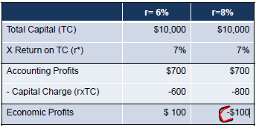

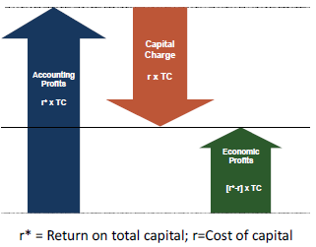

r* = return on total capital

r = cost of capital

Economic Profits = Spread = [r*-r] x TC

The Capital Charge measures the opportunity cost of money for your investment project:

Economic profits include a capital charge = r*TC

To create economic value, the investment project must earn positive economic profits, not just positive accounting profits.

### Managing for Value Creation EVA & MVA- Part 2: Measuring Financial Performance and Economic Profits

#### Creating Shareholder Value

Creating economic value for shareholders requires the corporation to earn positive economic profits.

Economic Profit ====> The corporation’s ability to earn positive economic profits depends upon :

1. operating efficiency
2. capital efficiency

#### Operating Efficiency Example – Income Statement

|  |  |  |
| --- | --- | --- |
| **Income Statements** | **Company A** | **Company B** |
| Sales | $100,000 | $100,000 |
| - Cost of Goods Sold | -70,000 | -65,000 |
| - Selling, General, and Adm. | -8,000 | -10,000 |
| - Other Expenses | -2,000 | -1,000 |
| Operating Profit (EBIT) | $20,000 | $24,000 |
| - Taxes (35%) | -7,000 | -8,400 |
| NOPAT Net Operating Profit (After-Tax) | $13,000 | $15,600 |
| **Return on Sales (ROS) = NOPAT/Sales** | **13.0%** | **15.6%** |

Measure of operating efficiency is the company’s Return on Sales (ROS). ROS tells us the fraction of each dollar sales that flows through to the bottom line using the Income Statement.

ROS =

Firm B is operating more efficiently at 15.6% versus firm A at 13%.

#### Capital Efficiency Example – Balance Sheet

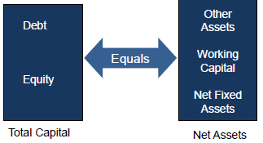

|  |  |  |
| --- | --- | --- |
| **Balance Sheet** | **Company A** | **Company B** |
| Net Working Capital | $10,000 | $15,000 |
| Net Fixed Assets | 98,000 | 147,000 |
| Other Assets | 2,000 | 3,000 |
| Net Assets | $110,000 | $165,000 |
| Long-Term Debt | $40,000 | $40,000 |
| Stockholders’ Equity | $70,000 | $125,000 |
| Total Capital | $110,000 | $165,000 |
| **Total Capital = Net Assets** | |  |

Total Capital is equal to the total amount of money contributed to the firm by both bondholders and stockholders.

Because sources of funds must equal uses of funds, Total Capital is equal to Net Assets.

Measure of capital efficiency is the company’s Capital Turnover (CT). CT measures the amount of sales that are generated for each dollar invested in the business.

|  |  |  |
| --- | --- | --- |
| **Income Statements** | **Company A** | **Company B** |
| Sales | $100,000 | $100,000 |
| **Balance Sheet** | **Company A** | **Company B** |
| Total Capital (TC) | $110,000 | $165,000 |
| **Capital Turnover (CT) = Sales/TC** | **90.9%** | **60.6%** |

CT = Higher is better efficiency

|  |  |  |
| --- | --- | --- |
| **Income Statements** | **Company A** | **Company B** |
| Sales | $100,000 | $100,000 |
| NOPAT Net Operating Profit (After-Tax) | $13,000 | $15,600 |
| **Balance Sheet** | **Company A** | **Company B** |
| Total Capital (TC) | $110,000 | $165,000 |
| **Return on Sales (ROS) = NOPAT/Sales** | **13.0%** | **15.6%** |
| **Capital Turnover (CT) = Sales/TC** | **90.9%** | **60.6%** |
| **ROTC = NOPAT/TC** | **11.82%** | **9.45%** |

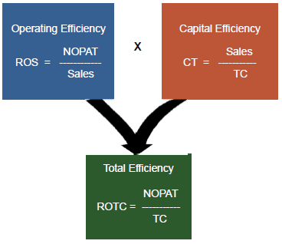

Company A has better use of capital for generating sales.

Overall Company A has better Return on total capital - ROTC or overall efficiency at 11.82%

#### Create Value By Looking at Where to Improve Efficiencies:

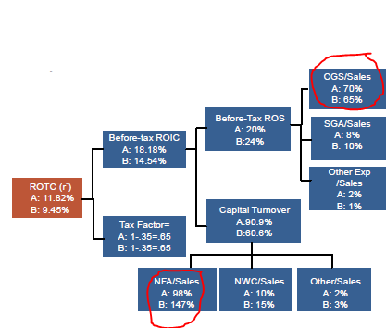

### Managing for Value Creation EVA & MVA- Part 3: Economic Profits Example and Comparison with NPV

Do either Company A or Company B create economic value for their shareholders? What criteria would you use to decide?

To determine whether Companies A and B are creating economic value for their shareholders we need to compute their economic profits. Recall that economic profits are equal to the difference between accounting profits and a charge for the cost of capital:

Economic Profit = Accounting Profit - Capital Charge Both methods produce the same answer:

= NOPAT - [ r x TC ]

or

= [r* - r ] x TC

Suppose the cost of capital for both of these companies is r = 10%. What are their economic profits?

#### Economic Value or Economic Value Added (EVA) Method 1

Total Capital x Cost of Capital (r=10%) x 10 % x 10 % Capital Charge

NOPAT - Capital Charge Economic Profits

#### Economic Value or Economic Value Added (EVA) Method 2

ROTC (r*) - Cost of Capital (r=10%) -10 % - 10 %

Spread = [r* - r]

|  |  |  |
| --- | --- | --- |
| **Balance Sheet** | **Company A** | **Company B** |
| Net Working Capital | $10,000 | $15,000 |
| Net Fixed Assets | 98,000 | 147,000 |
| Other Assets | 2,000 | 3,000 |
| Net Assets | $110,000 | $165,000 |
| Long-Term Debt | $40,000 | $40,000 |
| Stockholders’ Equity | $70,000 | $125,000 |
| Total Capital | $110,000 | $165,000 |
| **Income Statements** | **Company A** | **Company B** |
| Sales | $100,000 | $100,000 |
| NOPAT Net Operating Profit After-Tax | $13,000 | $15,600 |
| **Method 1: NOPAT - [r X TC]** | |  |
| r X TC | $11,000 | $16,500 |
| Economic Value = NOPAT - r X TC | $2,000 | ($900) |
| **Method 2: [r* - r] X TC** |  |  |
| r* is estimated by ROTC = NOPAT/TC | 11.82% | 9.45% |
| Economic Value = [r* - r] X TC | $2,000 | ($900) |

r given as 0.10 . Both methods produce the same value. Company A is the clear economic value winner.

#### Economic Profits

* Companies earns a positive economic profit only if the Return on Total Capital

(r*) is greater than its Cost of Capital ( r)

* Earning positive economic profit is key to financial success.
* Companies that cannot earn economic profits will find it difficult and expensive to attract capital from investors.
* Economic profits are also sometimes called Economic Value Added (EVA).

#### Net Present Value (NPV) and Project’s Economic Value (EVA)

The Net Present Value (NPV) can also be calculated by discounting a project’s economic profits (EVA) over its life.

NPV =

Discounting an investment’s Annual EVA Stream is equivalent to calculating the investment’s NPV. Four year life span.

|  |  |  |  |  |  |
| --- | --- | --- | --- | --- | --- |
| **Standard NPV Analysis** | **0** | **1** | **2** | **3** | **4** |
| Initial investment | ($100.00) |  |  |  |  |
| Revenue |  | $80.00 | $80.00 | $80.00 | $80.00 |
| Cash Expense |  | 13.33 | 13.33 | 13.33 | 13.33 |
| Depreciation |  | 25 | 25 | 25 | 25 |
| Income before tax |  | $41.67 | $41.67 | $41.67 | $41.67 |
| Tax at 40% |  | $16.67 | $16.67 | $16.67 | $16.67 |
| Income after tax |  | $25.00 | $25.00 | $25.00 | $25.00 |
| Depreciation |  | 25 | 25 | 25 | 25 |
| After tax cash flow | ($100.00) | $50.00 | $50.00 | $50.00 | $50.00 |
| r |  | 10% | 10% | 10% | 10% |
| NPVt | ($100.00) | $45.46 | $41.32 | $37.57 | $34.15 |
| **NPV = sum(NPV**t) | **$58.50** |  |  |  |  |

#### EVA Calculation Discounted EVA Analysis

Discounting an investment’s Annual EVA Stream is equivalent to calculating the investment’s NPV.

|  |  |  |  |  |  |
| --- | --- | --- | --- | --- | --- |
| **(b) Discounted EVA Analysis** | **0** | **1** | **2** | **3** | **4** |
| Capital employed - depreciation |  | $100.00 | $75.00 | $50.00 | $25.00 |
| r |  | 0.1 | 0.1 | 0.1 | 0.1 |
| r x Capital |  | $10.00 | $7.50 | $5.00 | $2.50 |
| EBIT(1 - t ) (Income after tax) |  | $25.00 | $25.00 | $25.00 | $25.00 |
| - r x Capital |  | $10.00 | $7.50 | $5.00 | $2.50 |
| EVA |  | $15.00 | $17.50 | $20.00 | $22.50 |
| NPVt |  | $13.64 | $14.46 | $15.03 | $15.37 |
| **EVA discounted at 10% (r)= sum(NPV**t) | | **$58.49** |  |  |  |

Same value: EVA same value as NPV in a different framework.

#### NPV of a project is the same as the discounted value of economic profits or discounted value of EVA

### Managing for Value Creation EVA & MVA- Part 4: EVA, MVA, & Unified Framework

Relationship or linkage between economic profits, stock prices, and market values. There is a high correlation between economic profits (EVA) and stock prices. EVA is reflected in present value of future economic profits.

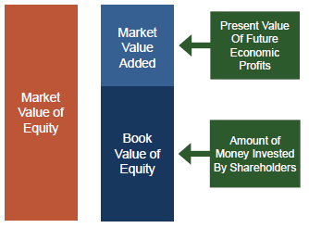Market Value Added (MVA) is the difference between the market value and book value of the company’s equity.

MVA = Market Value of Equity - Book Value of Equity

Book value of equity = Stockholder Equity

Market Value of Equity = Market Cap = # shares X price

MVA measures the total wealth created for shareholders by the corporation.

Recent information is given for Home Depot in the following page. Use this information to calculate Home Depot’s MVA.

MVA = Stock Price X # Shares Outstanding - (Assets – Debt from balance sheet OR Stockholder Equity)

Book Value = Assets – Debt from balance sheet = Stockholder Equity

MVA = ( Stock Price per share – Book Value per share) * Number of shares outstanding

Stock Price per share _____$205.66__________

- Book Value per share ____-1.70______

= Market Value Added per Share ___207.36____________ (added from market per share)

X Number of Shares Outstanding ____1.1B___________

= Market Value Added (MVA) ____$228B___________ (added from market)

Investors think the company is so good that they will see future sustainable growth.

#### MVA vs. Economic Value

A large positive MVA of publicly traded company represents the belief that the company can achieve return on invested capital which exceeds the capital cost over a sustained period in future. This expectation is based upon the notion that the company has a sustainable competitive advantage.

#### Sources of Competitive Advantage

* Markets - GE
* Brand - Coca-Cola, Altria
* Product Development - Apple
* Cost Leadership - Walmart, Home Depot

#### Good Predictor of ΔMVA using Regression – Choose EVA which explains 40%.

Human capital also creates value.

#### Creating Economic Value

Investors value companies based upon their ability to produce economic profits. There are basically three ways a company can improve its economic profits and increase its stock price:

1. Manage: Increase efficiency of existing operations and thus improve the spread between r* and r.
2. Build: Invest in businesses and projects with positive spreads between r* and r.
3. Harvest: Withdraw capital from operations or activities where r* is less than r.

#### Incentive-Based Compensation and Economic Profits

Many companies use economic profits (EVA) to determine performance-based compensation.

Advantages of economic profits as a measure of performance:

* Rewards managers for what shareholders value the most economic profits.
* Accounts for all the costs associated with running a business, including the cost of capital.
* Gives managers the incentive to improve both operating efficiency and capital efficiency.
* Provides a clear-cut benchmark for evaluating performance.

### Summary of Finance Modules

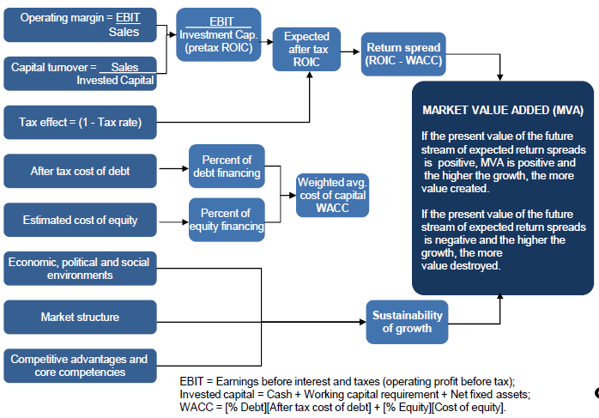

* The economic value created by the long-lived investment projects is measured by the Net Present Value (NPV).
* To create value for shareholders, invest in projects with positive NPV.
* Stocks are valued as the present value of all future expected dividends.
* The cost of equity depends upon
  + (i) the current level of interest rates and
  + (ii) the risk of the stock.
* Risk is measured by the stock’s beta.
* The Capital Asset Pricing Model (CAPM) provides a practical method for estimating the cost of equity based upon the stock’s beta.

Cost of Equity = Treasury Bond Rate + (Market Risk Premium) x Beta

* The cost of capital is the minimum rate of return the corporation must earn on its invested capital in order to compensate for the time value of money and risk.
* The cost of capital is a weighted-average of the cost of debt and the cost of equity. This is called the Weighted Average Cost of Capital (WACC).

WACC = Cost of Debt x (1-Tax Rate) x (Debt/(Debt+Equity)) + Cost of Equity x (Equity/(Debt+Equity))

* The value of a firm is the present value of projected free cash flows discounted at its weighted average cost of capital.
* Economic Profits measure the value created for shareholders in a given year. Earning positive economic profits is the key to financial success for any business.

Economic Profits = NOPAT - [r x Total Capital]

= [r* - r] x Total Capital

* Stock Prices are highly correlated with changes in the company’s economic profits.
* Market Value Added (MVA) measures the total wealth created for shareholders by management. It reflects investors’ confidence in the company’s ability to create economic profits in the future.

MVA = Market Value of Equity - Book Value of Equity

#### Glossary

r* -Return on total capital. Potential investment return.

r - Cost of capital. Company’s risk rate of return to compare for economic value

Beta - A measure of market risk of a stock i.e. risk that cannot be diversified away.

Compounding - The growth of a sum of money over time through the reinvestment of interest earned to earn more interest.

Cost of equity - Return equity investors expect to earn by holding shares in a company. The expected return foregone by equity investors in the next best equal-risk opportunity.

Discounting - Process of finding the present value of future cash flows.

Economic Value Added - A business’s or a business unit’s operating income after tax less a charge for the opportunity cost of capital employed. It is computed by taking the spread between the return on capital and the cost of capital, and multiplied by the capital outstanding at the beginning of the year.

Internal rate of return - Discount rate at which the which the project’s net present value equals zero.

# VIDEO CONFERENCE 6/16/2021

P10 = 15.75 + 15.75*10.48/(.12 -.048) = 245

PV of 245 in year 10 at 12% r = 245/(1+.12)^10

=78.88

* 1. is P0. Plus is present value of 229.25 at terminal value as P1

NPV/IRR exercise problem 1

IRR = NPV = 0 = 35000 – 4000/(r-0.04) r=IRR = 15.43%

Rank by NPV to find best option.

22 problems on the exam including a NPV/IRR exercise as an example problem.

Risk free rate = treasury bond rate

Default premium from bond rating basis points

100 basis points are 1%

Cost of Debt = Treasury Bond Rate + Default Premium

Cost of Equity = Treasury Bond Rate + (Market Risk Premium * Beta)

FCF = (EBIT*(1-t)) + Depreciation – Capex – Change in WC

FCF = ((EBITDA – Depreciation) * (1-t)) + Depreciation – Capex – Change in WC

NPV equation: An excel macro was used to calcualte NPV The macro is NPV(.1,C7:F7)

working capital goes up = cash outflow

Working capital goes down = cash inflow

But if the change is - (working capital goes down) by subtracting you are adding which is what you should do

Terminal value – use FCF for terminal year.

# EXAM II DUE 06/31 Finance

# Supply Chain Management

## Week 6 06/21 – 06/27 Introduction to Supply Chain Management and Long-Term Decisions

The goal of the supply chain management module is to introduce the student to the importance of operations and supply chain management in the business organization. Students will be exposed to the main challenges of managing a global supply chain and several best practices from leading firms will be highlighted. In addition to developing a basic understanding of supply chain business practices and strategy, this module will introduce students to several key operational level models or quantitative methods used in specific decision situations including the Newsvendor model that provides insight into matching supply with demand and using Economic order Quantity ("EOQ") and reorder point analysis ("ROP") to establish inventory policy.

While most students think of supply chain management as the domain of companies that make a product, the module highlights the importance of supply chain to the service industry as well. The module concludes by examining a phenomenon called the bullwhip effect and students will learn how the bullwhip effect distorts demand in a supply chain.

Focus on Upstream – looking at suppliers into organization.

## Downstream – looking at distributors and customers.

3 levels:

1. How it is configured (centralized, decentralized, cost driven, responsive)
2. Operational decision making – inventory, economic, order up to inventory policy
3. Forecasting and errors

## Week 7 06/28-07/04 Medium Term Decisions

# HOMEWORK #2 Supply Chain Simulation Assignment DUE 07/06

## Week 8 07/04 – 07/11 Short Term Decisions

# EXAM III DUE 07/12 Supply Chain Management

# Marketing

## Week 9 07/12 – 07/18 Marketing Strategy, Opportunity Analysis, and Segmentation

A sound marketing strategy is grounded in a detailed understanding of consumer needs/wants and focused on creating offerings that exceed customer expectations. To accomplish this outcome, students will learn how marketers assess opportunities via a rigorous analytical process that contemplates broader strategic considerations such as competitive offerings (both direct and indirect), the organization’s competencies, and contextual considerations. Students will also be exposed to approaches used by marketing management to determine target market segments and how to develop a precise marketing mix for each segment.

Understanding how customers think about brands and analyzing opportunities for differentiation is critical for marketing success. Marketers and data scientists are responsible for evaluating the buyer journey to determine ways to create awareness, engage customer interests, and drive consideration and conversion. Students will learn how elements such as branding, packaging, warranties, and product classes must be considered when developing products and services. Students will examine how a product’s “lifecycle” can be managed by stage; and the importance of lifecycle in determining strategies essential to maintain sustainable competitive advantage.

Finally, students will also be exposed to the other elements of the four “Ps” of marketing (also known as the “marketing mix”): Product, Pricing, Place, and Promotion. Issues and considerations will be discussed as they relate to 1) developing effective and efficient channel systems and distribution models; 2) crafting pricing objectives and policies along with determining customer value; and 3) creating promotion methods that maximize both digital and traditional modalities of communication along with assessing factors related to personal selling, PR, managing customer service, and establishing sales promotions.

Customer needs and solutions that are superior to competitors. Understand customer behavior and. Need to know customer.

Segments

product

Prioritize Segments into priority target markets.

Position product and strategy

Marketing

Marketing is the activity, set of institutions, and processes for creating, communicating,

delivering, and exchanging offerings that have value for customers, clients, partners, and society

at large.

Customer behaviors - Individuals, groups or organizations and the processes they use to select,

secure, use and dispose of products, services, experiences, or ideas to satisfy needs and the

impacts that these processes have in return.

Marketing research is the function that links the consumer, customer, and public to the

marketer through information--information used to identify and define marketing

opportunities and problems; generate, refine, and evaluate marketing actions; monitor

marketing performance; and improve understanding of marketing as a process. Marketing

research specifies the information required to address these issues, designs the method for

collecting information, manages and implements the data collection process, analyzes the

results, and communicates the findings and their implications.

Strategic marketing - An endeavor by a business unit to differentiate itself positively from its

competitors, using its relative corporate strengths to better satisfy customer needs in a given

environmental setting

Market Segmentation is the process of placing the buyers in a market into sub-groups so that

the members of each segment display similar responsiveness to a particular positioning

strategy.

The target selection decision identifies the segment or segments of people or organizations in a

market toward which a firm directs its positioning strategy.

Positioning refers to placing a brand in that part of the consumer’s mind where it will have a

favorable reception compared to competing products, essentially positively differentiating itself

from the competition

Topic 1 Introduction to marketing

Lesson 1 what is marketing and why is it important

Makes sure right goods and services are produced, creates customer satisfaction

Lesson 2 history of marketing and its dynamic role in the business environment

Simple trade era – focuses on sell surplus

Production era – focuses on increases supply

Sales era – focuses on beat competition

Department era – focuses coordinate & control

Marketing company era – focuses long-run customer satisfaction

Shifting from a process to organizational function

Lesson 3 the marketing process

Elements of the marketing process

• Environmental influences

o political/legal env, technological env, economic env, social env

o direction marketing – competitive env, customers, resources and objectives of

the company

• Customer behavior

• Market research

• Strategic marketing – segmentation, target selection, positioning

• Marketing strategy – product, distribution, promotion, price

Target market => price + product + place + promotion

Three components

• Company – objectives + resources + capabilities

• Competitors – current + potential

• External market environment - economic + technological + political/legal +

cultural/social

Lesson 4 customer behavior

• B2B – business and organizational customers and their behaviors

o Key characteristics = manufacturers, producers of services, retailers, wholesalers,

government units, non-profit

o Key differences = multiple buying influence, emphasis on economic needs, more

systemic and formal evaluation of choices, purchase criteria & specifications

o Buying center – buyers, users, influencers (expertise), gatekeepers, deciders

• B2C – final customers and their behaviors

Lesson 5 market research

Define the problem (most difficult but most critical), analyze the situation, getting problem

specific data, interpreting the data, solve the problem

All data sources

• Secondary data sources – inside company (company files, intranet, reports, sales,..),

outside company (internet, libraries, governments, trade associations, ..)

o Inexpensive, fatser, easier, what more is needed, primary data research proposal

• Primary data sources – observations (equipment, website analysis), questioning (indepth

and focus group interview, online, mail, phone)

o Questioning – qualitative (un-structured, open-ended, variable responses, indepth

information), quantitative (structured, closed-ended, fixed responses)

Marketers can create wants and preferences

A marketing intermediary would most likely help a firm by moving the firm's goods from

production points to distribution centers

Topic 2 strategic marketing

Lesson one introduction to strategic marketing

Strategic marketing planning process – narrowing down to the best opportunities + developing

a strategy

Lesson two components of strategic marketing

Understanding the broad market leads to identifying potential opportunities

Identify your company’s market + focus on the customer not just the product + generic markets

to product-markets + adjust market definitions to find opportunities

Generic market definition = customer needs + customer types + geographic area

Product market definition = customer needs + customer types + geographic area + product type

The strategic marketing processes

• Identify markets with broad similar needs

• Determining market segmentation

• Selecting market to target

• Position through marketing strategies

Lesson three/four/five the segmentation process

Segmentation strategy

• Market identification

• Decision how to segment

• Formation of segments

• Strategic analysis of each segment

• Further segmentation

The marketing segmentation process

• Find ways to group customers according to their needs

• Find ways to group marketing actions – usually the products offered – available to the

organization

• Develop a market/product grid to relate the market segments to the firm’s products and

actions

• Select the product segments toward which the firm directs its marketing actions

• Take marketing actions to reach target segments

Bases for segmentation

• Customer characteristics – psychographic, demographic, geographic, socioeconomic

• Buying situation – behavior, outlets, benefits, usage

Segmentation vs. combing

• Combiners try to satisfy pretty well

• Too much combining is risky

• Segmenting may produce bigger sales

• segmenters try to satisfy very well

• Segment or combine?

• Profit is the balancing point

Requirements for segmentation

• Identifiable segments (age, income)

• Homogeneity within

• Heterogeneity across

• Actionable segments

• Profitable size

• Stability over time

Segmenting dimensions for business markets – types of customer + demographics + product

use + purchase situation + kind of relationship + purchasing methods

Lesson six target segment selection

Target selection strategy

• Selective targeting – selected niche, product specialization

• Extensive targeting – multiple segments, product variety

Target market dimensions Marketing strategy implications

Behavioral needs, attitudes, and how present

and potential goods and services fit into

customers’ consumption patterns

Affects product and promotion

Urgency to get need satisfied and desire and

willingness to seek information, compare and

shop

Affects place and price

Geographic location and other demographic

characteristics of potential customers

Affect size of target markets, place,

promotion

Lesson seven/eight/nine the positioning

Positioning concept = functional + experiential + symbolic

How should we position? By attribute and benefits, by price and quality, by use or application,

by product class, by product user, by competitor, by cultural symbols

Developing a position platform

• Identify the competitors

• Assess perceptions of them

• Determine their positions

• Analyze customer preferences

• Make the positioning decision

• Monitor the position

For (our target market), (our brand) of all (product type) delivers (key benefits or point of

differentiation) because (our brand) is (reasons to believe).

Position errors - Doubtful positioning, confused positioning, over-positioning, under-positioning

Topic 3: Marketing Strategy & The Marketing Mix

lesson 1: Elements of Product Strategy

• Product components

• Good vs. services

• Business products

Core – product attributes that most directly satisfy or meet the customer’s need or needs

Packaging – product features that surround the core and enhance the product’s ability to satisfy

customer needs

Support services – services and product features that help maintain or insure the product’s

ability to continue satisfying customer needs

Goods vs. services = tangibility, inseparability, perishability, durability, quality consistency

Business product strategy – derived demand, inelastic industry demand, tax treatments diff

Lesson 2 new product strategy & development

• New product development strategies

o Reposition / cost reduction / new to world products / new product lines

• New product development process

o CUSTOMER NEEDS ANALYSIS

o IDEA GENERATION

o SCREENING & EVALUATION

o BUSINESS ANALYSIS

o MARKETING STRATEGY

DEVELOPMENT

o PRODUCT DEVELOPMENT

o TESTING

o COMMERCIALIZATION

o FEEDBACK

• New product development & market diffusion

Lesson 3 distribution strategy

Distribution strategy – direct vs. indirect, distribution arrangement, distribution intensity,

distribution configuration

Direct systems – greater control, lower cost, internet makes direct easier, direct contact with

customers, suitable intermediaries not available

Decision criteria – cost, capital, coverage, control, content, congruency

Lesson 4 distribution logistics & intermediaries

Keys affect consumers’ retail choice – product selection, place decision, promotion, prices,

emotional needs, shopping atmosphere,

Internet retailing issues – new meaning of convenience, showrooming, big data, online costs for

retails & customers, brick & mortar stores add online capabilities

Wholesalers – changing with the times, in decline, progressive wholesalers adapt, goodbye to

some, ethical issues, new strategies needed to survive

Type of merchant wholesalers

• Service – general merchandise, single line, specialty

• Limited function – cash and carry, drop shippers, truck, rack jobbers, catalog

Lesson 5/6/7 integrated marketing communication (IMC) methods & process

Promotion methods, managing promotion, communication process

IMC objective and strategy => role of IMC components => IMC budget => component stragegies

Advertising managers + sales managers + sales promotion managers + marketing managers

IMC component strategy – target audience => objectives (informing, persuading, reminding) =>

budget (percent of sales, arbitrary, comparative parity, affordable method, return on

investment ROI, objective & task) => creative strategy => media strategy => PRODUCTION &

EXECUTION => EVALUATION OF EFFECTIVENESS (sales and expenses analysis, recall tests,

ratings services, controlled tests, test marketing)

AIDA – get attention, hold interest, arouse desire, obtain action

Appeal methods

• functional appeal – feauture, competitive, price, news, popularity

• image appeals – visual, audio /verbal, touch, taste, smell

• emotional appeals – humor, sex, fear, love, other emotions

media selection

• imc objectives

• target audience characteristics

• funds available

• reach & frequency

Lesson 8 pricing strategic options

Skimming strategy – neutral strategy – penetration strategy

Pricing situations – new product pricing, life cycle pricing, positioning strategy change,

countering competitive threads

Analyzing the pricing situation – customer price sensitivety, legal and ethical constraints,

competitors’ likely responses, product costs

Business strategy and innovation

Planning is defining organizational goals, establishing a strategy for reaching those goals, and

developing a comprehensive hierarchy of plans to integrate and coordinate activities. It can be

either formal or informal, depending on the time frame and amount of documentation

Introduction to business strategy

Lesson 1 what is planning

Defines organizational objectives and goals

Develops overall strategies, tactics, and activities necessary to achieve the goals

Creates a hierarchy of plans that guides the firm at each level of the organization

Planning -> organizing -> directing -> controlling

Lesson 1 why planning is important

Planning provides direction that can align all the activities of the organization

Planning reduces the uncertainty

Planning establishes organizational goals and standards

Planning can improve employee engagement throughout organization

Factors that affect planning

• organizational level – impacts the type and scope of plan prepared

• degree of environmental uncertainty – impacts the planning methodology, specificity of

the goals and planning time horizon

• length of future commitments – impact the planning time horizon

lesson 2 types of plans

strategic plans

• apply broadly to the entire organization. Developed at corporate or business unit (SBM)

level, are the responsibility of senior management

• establish the organizational overall mission, goals, and objectives. Goals tend to be

directional rather than specific

• seek to position the organization in terms of its external of external environment. The

focus is on creating and sustaining a competitive advantage

• are the basis for the functional plans which are typically developed concurrently with

the SBM plans?

• cover extended period time

functional plans

• planning related to a specific business function. Example: R&D, supply chain, sales,

human resources, marketing, financial, manufacturing,

• driven by goals developed in strategic planning, translated into more specific,

operational goals at the business function level

• functional plans are interrelated, and the development of functional plans are typically

managed by senior level executive committee

• responsibility of upper level middle management

operational plans / tactical

• narrow focus – usually apply to specific activities of the organization, example,

production schedules, sales call schedules

• prepare daily, weekly, monthly, and often standing plans

• are developed at any managerial level but primarily the responsibility of first level

supervisors and team leaders

contingency plans

• address the what ifs – incorrect planning assumption or the realization of known risks

• when needed

o to mitigate a critical planning assumption or business risk

o to min business disruption due to natural disasters, a failure in a critical

production process,

lesson 3 what is business strategy

business strategy – The goal directed actions a firm intends to take in its quest to gain and

sustain competitive advantage.

Competitive advantage is superior performance relative to other competitors in same industry

Competitive parity is when two or more firms in the same industry perform at the same level

Competitive disadvantage is firm underperformance relative to competitors in the same

industry

A Competitive Advantage is NOT sustainable if the source of advantage can be independently

attained or easily imitated

Firm effects result from the quality of the firm’s Business Model and the alignment and

effectiveness of firm Business Strategy

Lesson 4 business model

A firm’s BUSINESS MODEL is how the various components of the business fit together to

produce a profit. A business model is the end results of decisions and tradeoffs made by

management in formulating strategy

Typical Components of a Business Model:

• Markets Service Served: Products (value propositions); Customer; Channels; and

relationships

• Firm Infrastructure: Processes and technology; People and Culture; and Strategic

partnerships

• Economic Model: Cost drivers and revenue models

Cost-leadership strategy

Becoming the lowest-cost producer in an industry. Business model emphasis on use of

technology to drive down operational costs, simple, standardized product designs, and a focus

on driving costs down

Differentiation strategy

Attempting to be unique in an industry within a broad market. Making products unique to allow

the company to charge a premium price. Creative design and clever marketing, emphasis on

R&D and and higher quality inputs to create customer value

Focus strategy (Segmentation)

Attempting to establish an advantage (such as cost or differentiation) in a narrow market

segment.

The core competencies of a firm are its unique capabilities and resources that enable the firm

to deliver and support a value proposition to its customer

Capabilities consist of the firms resources and how those resources are combined and

integrated into functional business processes and business activities that support the value

proposition and competitive strategy

To be competitive a firm must have unique and valuable resources and the capability to exploit

these OR a unique capability to manage a relatively common resource.

Lesson 5 business model case study

Lesson 6 level of strategy

• Corporate Strategy – addresses which businesses an organization will be in; how

resources will be allocated among those businesses; and how each business will relate

to the other. Also sets the “grand strategy” – growth, stability, defensive – for each

business unit.

• Business Strategy – focuses on how to compete in a given business. Strategy here is

about creating and sustaining a competitive advantage

• Functional Strategy– concerned with the activities of the different functional areas of

the organization and the short to long term methods to be used to help achieve the

overall business strategy Example: Marketing develops a one to three year product

development and roll-out plan that supports the overall business objective of 10%

growth in overall revenues. The functional plan then can be divided into one year

operation plans with budgets. Marketing may also develop other plans in areas such as

distribution, promotion, and pricing

Grand strategy – growth, stability, renewal

Growth strategy –

Concentration: growing by focusing on the firms core business – its primary business – and

increasing the number of products or services offered or the number of markets served

Diversification: growing by moving into a different industry. Strategy here is typically

determined at the corporate level

Vertical Integration: growing by gaining control over either the firms inputs (suppliers) or

outputs (distributors/retailers). Growth through acquisition

Horizontal Integration: growing by combining with a competitor. May be an acquisition or

merger

The strategic management process

Lesson 1 introduction to strategic management process models

AFI framework

• Analysis – vision, mission, values, external and internal analysis

• Formulation – corporate, business, functional strategy

• Implementation – structure, culture, processes, capabilities, technology, goernance,

controls, business ethics

Lesson 2 vision, mission, values, strategic intent

the vision statement is an expression about what the organization ultimately wants to

accomplish

strategic intent is the staking out of a desired leadership position in the industry. The focus is

on the future and the attainment of ambitious, challenging goals

mission statement provides a statement of how the organization intends to achieve its vision

and the organization’s responsibilities towards the organization key stakeholders

core values – what the company believes to be important

goal – financial goals (profitability), strategic goals (markets, product, financial and HR,

productivity, research and innovation, sustainability)

lesson 3 strategic planning under uncertainty

uncertainty – (market factors) direct and indirect competition, suppliers, customers,

communities, (industry factor) technology, socio-cultural, economic, political/regulatory,

ecological, legal, globalization

level 1 – a clear enough future

level 2 – alternative but well definable futures

level 3 – a range of potential futures

level 4 – true ambiguity

lesson 3 scenario planning

level 1 – traditional planning

level 2 & 3 scenario planning

lesson 4 strategy as planned emergence

In many cases the realized strategy of the firm is a combination of a top-down intended

strategy – either driven by the traditional strategy developed process or by scenario planning

AND bottom up emergent strategies that could be prompted by unexpected changes changes

in the external environment or ideas that just pop up from within the organization.

Strategy as Simple Rules is a approach where management defines certain guidelines that then

provide direction to more junior management in terms of identifying and championing

potential strategic initiatives. In the final video lesson five areas were defined where rules are

typically established. In the list below identify each of these five areas

How-to, boundaries, prioritization, timing, exit

External analysis

Lesson 1 components of the external env and how they affect strategy

Lesson 2 PESTEL framework

• Political – subsidies, favorable tax politices, regulated acces or pricing control, grants

and investment, trade controls/import restrictions,

• economic – growth rate, interest rates, inflation rate, cost of capital, level of

employment, currency exchange rates, price stability,

• socio-cultural – culture norms and values and demographics, life expectancies, aging

population, changes in ethnic composition, immigration, work force diversity, rising

affluence, increasing lifestyle changes, societal values, attitudes towards product

classes, quality, safety,

• technology – relentless application of knowledge to create new products and processes,

IP protection, industrial spending on R&D, digital communication, emerging industries,

technology transfer

• environment – ecological, braod env issues, workforce health plus society’s changing

view of business responsibility,

• legal – law, mandates, regulation, court decisions, hiring and promotion laws, antitrust

regulation, environmental protection laws, data security, intellectual property

lesson 4 the structure-conduct-performance continuum

Lesson 5 the porter five process model

Porters Five Forces Model identifies 5 competitive forces that managers consider when

analyzing the external environment and formulating strategy.

As a rule of thumb, the stronger the industry forces, the lower the industry profit potential –

making industries less attractive.

backward integration – firm purchases

or becomes its own supplier

forward integration – firm builds its

own distribution

Bargaining Power of Suppliers

Suppliers can suppress the profitability of the industries to which they sell by raising prices or

reducing the quality of the components they provide.

Size/Concentration, Forward Integration, Available Substitutes, Buyer (customer), Price

Sensitivity, Switching Costs

Bargaining Power of Buyers

Volume, Buyer Concentration, Switching Costs, Backward Integration, Available Substitutes,

Product Standardization, Importance of Price Paid

Threat of Substitutes

Number of Substitutes, Switching Costs, Performance of Substitutes

Threat of New Entrants

Capital Requirements, Intellectual Property, Government Regulation, Switching Costs, Product

Differentiation (and Branding), Access to Distribution Channels, Economies of Scale

Rivalry Among Existing Firms

Concentration ratio, Exit Barriers, Growth Rate of Industry, Product Differentiation, Branding,

Switching Costs, Economies of Scale

Attractive industry – weaker five forces, high profit potential, sustainable competitive

advantage easier

Change industry structure

• Abrupt Changes Driven by Macro-Forces

• Technological developments and innovation

• Significant regulatory (or deregulatory) change

• Change in customer behaviors

• Changes in Structural Factors (Five Forces)

• Changes to barriers to entry

• Strategic decisions from non-competitors

• Increases/decreases in supplier/buyer power

• Shifting substitution threat

• New bases of rivalry

• Structural Factors Can Be Shaped Through Strategy

• Each of the Five Forces are Subject to Influence

• Use tactics to increase value captured by the firm

• Larger competitors have a clear advantage here

Lesson 9 the strategic role of complements

Lesson 10 strategic groups and competitor analysis

• Competitor Information

• Who are our present and likely future competitors?

• What are the positions that the competitors have established in the marketplace?

• What are their strategic objectives and initiatives?

• What are their present and future strategies?

• What are their strengths and weaknesses?

• How are competitors likely to respond to our strategic initiatives?

• Approaches/Sources

• Websites

• Trade Shows

• Industry News

• Customers (of Competitors)

• Former Employees (be careful here)

• Consultants and Industry Databases

• The Firm as a Learning Organization

• SEC.gov Website (publically-held competitors)

A Strategic Group

• A Strategic Group is a set of companies that pursue a similar strategy within a specific

industry in their quest for competitive advantage. These firms target the same customer

groups and with similar value propositions.

• Strategic Groups can differ from other industry competitors along a number of dimensions:

Product and Product Differentiation, Quality, Pricing, Technology, Service and Support,

Research, Development, and Product Innovation, Distribution Channel, Target Customers.

• Firms in the same Strategic Group are direct competitors. The rivalry with a Strategic Group

is more intense than rivalry between Strategic Groups

(False). The intensity of competitive rivalry within an industry decreases in markets that are

characterized by slow growth, high fixed costs, and significant barriers to entry.

(true) The more substitutes a product has and the greater the propensity for a buyer to

substitute, the more elastic its demand curve will be.

Topic 4 internal analysis

Lesson 1 looking inside the company for the sources of competitive advantage

Core Competencies – unique strengths that drive competitive advantage

Resources – tangible and intangible assets of the firm

Capabilities – organizational and managerial skills

Activities – transform inputs into outputs

Lesson 2 the resource-based view of competitive advantage

Tangible & intangible => heterogeneous + immobile => VRIO resources => competitive

advantage

Lesson 3 VRIO

a framework for assessing firm resources to predict their value in terms of supporting a firm’s

competitive advantage in the marketplace

Why Resources are Difficult to Imitate

• Historical Conditions

• Causal Ambiguity

• Social Complexity

Lesson 4 Value Chain Analysis and Benchmarking

The Value Chain describes the internal activities a firm engages in when transforming inputs

into outputs

Lesson 5 SWOT analysis

A resource must be VRIO if it can help drive a sustainable competitive advantage. One condition

of VRIO is costly to imitate (the "I"). In the video lesson we discussed why resources can be

costly to imitate. Which ONE of the following is NOT a reason discussed. – cultural dependency

An Internal Analysis, the 3rd step in the traditional top-down strategic management process

helps identify the company’s strengths and weakness

Topic 5 formulating business unit strategy

SUB strategy – understanding environment, identifying opportunities, developing capabilities,

alignment to corporate priorities

Grand strategy – growth (concentration, vertical integration, horizontal integration,

diversification), stability, renewal

Ansoff’s Matrix existing market/new market, existing product/new product

Porter 3 Strategy (Cost-leadership strategy, Differentiation strategy, Focus strategy)

Henderson and Clark Model component knowledge / architectural knowledge

incremental (sustaining) and efficiency

innovation – core business, improve existing, less

risk, quick payback

architectural, disruptive, radical innovation –

divert from core business, high risk, delayed

profits

Topic 6 formulation corporate strategies

Lesson 1 introduction

Levels of strategy

• Corporate strategy – Addresses which businesses an organization will be in, how

resources will be allocated among those businesses, and how each business will relate

to the other.

o Scope of the Overall Firm

o Allocation of Resources Across Strategic Business Units

o Overall Firm Structure and the Extent of of Shared Services and Intra-SBU

Cooperation

o Establishment of SBU Specific Grand Strategies and Strategic Goals and

Objectives

o Strategic Alliances with other Firms

• Business Strategy - Focuses on how to compete in a given business – directed towards

achieving a sustainable competitive advantage

• Functional Strategy - Concerned with the activities of the different functional areas of

the organization and the short-range methods to be used to help achieve the overall

business strategy

Lesson 2 firm scope and the allocation of resources

Creating more values together

• Strong Internal Capabilities

• Sharing of Technologies and Resources

• Cost-Effective Capital

• Reinforcing a Strong Brands

Important when competing in multiple industries Corporate strategy concerns the SCOPE of the

firm

• Industry value chain – degree of vertical integration.

• Products and services – horizontal integration, diversification

• Geography – where to compete on the global stage.

GE-McKinsey 9 box matrix – invest / grow + selectivity / earnings + harvest / divest

Cost reduction by creating efficiencies from

specialization and standardization, economies of scale, and eliminating redundancies.

Lesson 4: Vertical Integration (Part 1)

Benefits

• Secures critical supplies and distribution channels

• Creates a source of differentiation

• Lowers costs

• Improves quality

• Facilitates scheduling and planning

• Facilitates investments in specialized assets

• Captures greater profits (profits that would typically

accrue to 3rd parties)

Risks

• Increases costs and or reducing quality

• Capacity balancing issues

• Internal suppliers lose incentives to compete

• Requires different core competencies

• Reduces flexibility

• Requires substantial capital

• Slow to respond to changes in technology or demand

Lesson 6 horizontal integration

Benefits

• Reduction in competitive intensity by increasing industry concentration and the

reduction of excess capacity

• Lower costs through economies of scale

• Increased differentiation by filling gaps in the acquiring firms product and service

offering

• Access to new markets and channels often through geographic expansion

Integration Failure – In many cases the proposed synergies of an integration strategy never

materialize and shareholder value is destroyed rather than created.

Lesson 7 diversification

Market diversification. Active in several

market segments or different geographical

locations

Product diversification. Active in several

different product categories

Product – market diversification. Active in a

range of both product and markets.

Benefits

• Create Economies of Scale and Scope

• Better Leverage Managerial Skills

• Cross Subsidize Products

• Spread Financial Risks Over Different

Markets

Topic 7 strategy implementation

Lesson 1 strategy implementation

John Kotter’s strategy implementation

• Establish a sense of urgency

• Create a guiding coalition (position power, expertise, credibility, leadership)

• Develop a vision and strategy (simple, vivid, repeatable, invitational)

• Communicate the change vision

• Empower employees for broad base action

• Generate short term wins

• Consolidate gains and product more change (change barriers: structural barriers,

troublesome supervisors)

o Cultural change comes last, not first

o Success must be visible, well communicated

o Some people will not make the transition Reinforce new norms and values with

incentives and rewards

• Anchor new approaches in the culture

Failure

• Lack of Senior Management Ownership

• Lack of Communication

• Getting lost in the day-to-day operations of the firm

• Getting overwhelmed

• Poor Planning effort

• Insufficient commitment of human capital and financial resources

• Poor program management

• Failure to link employee incentives to strategy

• Lack of empowerment

False According to Porter being "stuck in the middle" is when a firm is growing at the same rate

as the overall market and unable to develop a breakout strategy.

## Week 10 07/19 – 07/25 Positioning, Buying Behaviors, and Product Development

Marketing 4 p’s to generate demand

* Place
* Product
* Price
* promotion

# HOMEWORK #2 Marketing Data Analytics Simulation: Strategic Decision-Making DUE 07/27

## Week 11 07/26 – 08/01 Place Development, Pricing, and Promotion

# EXAM IV DUE 08/02 Marketing

Course pack.

Everything is in canvas.

Startup & syllabus